EC2

AWS Solutions Architect Associate

# Section 5: EC2 Fundamentals

## 29. EC2 Basics

* EC2 user data runs with the root user; means – all commands in user data will have the sudo rights.
* If you stop an EC2 instance and start it again,
  + public IPv4 will change
  + private IPv4 will remain the same

## 32. EC2 Instance Type Basics

### General Purpose

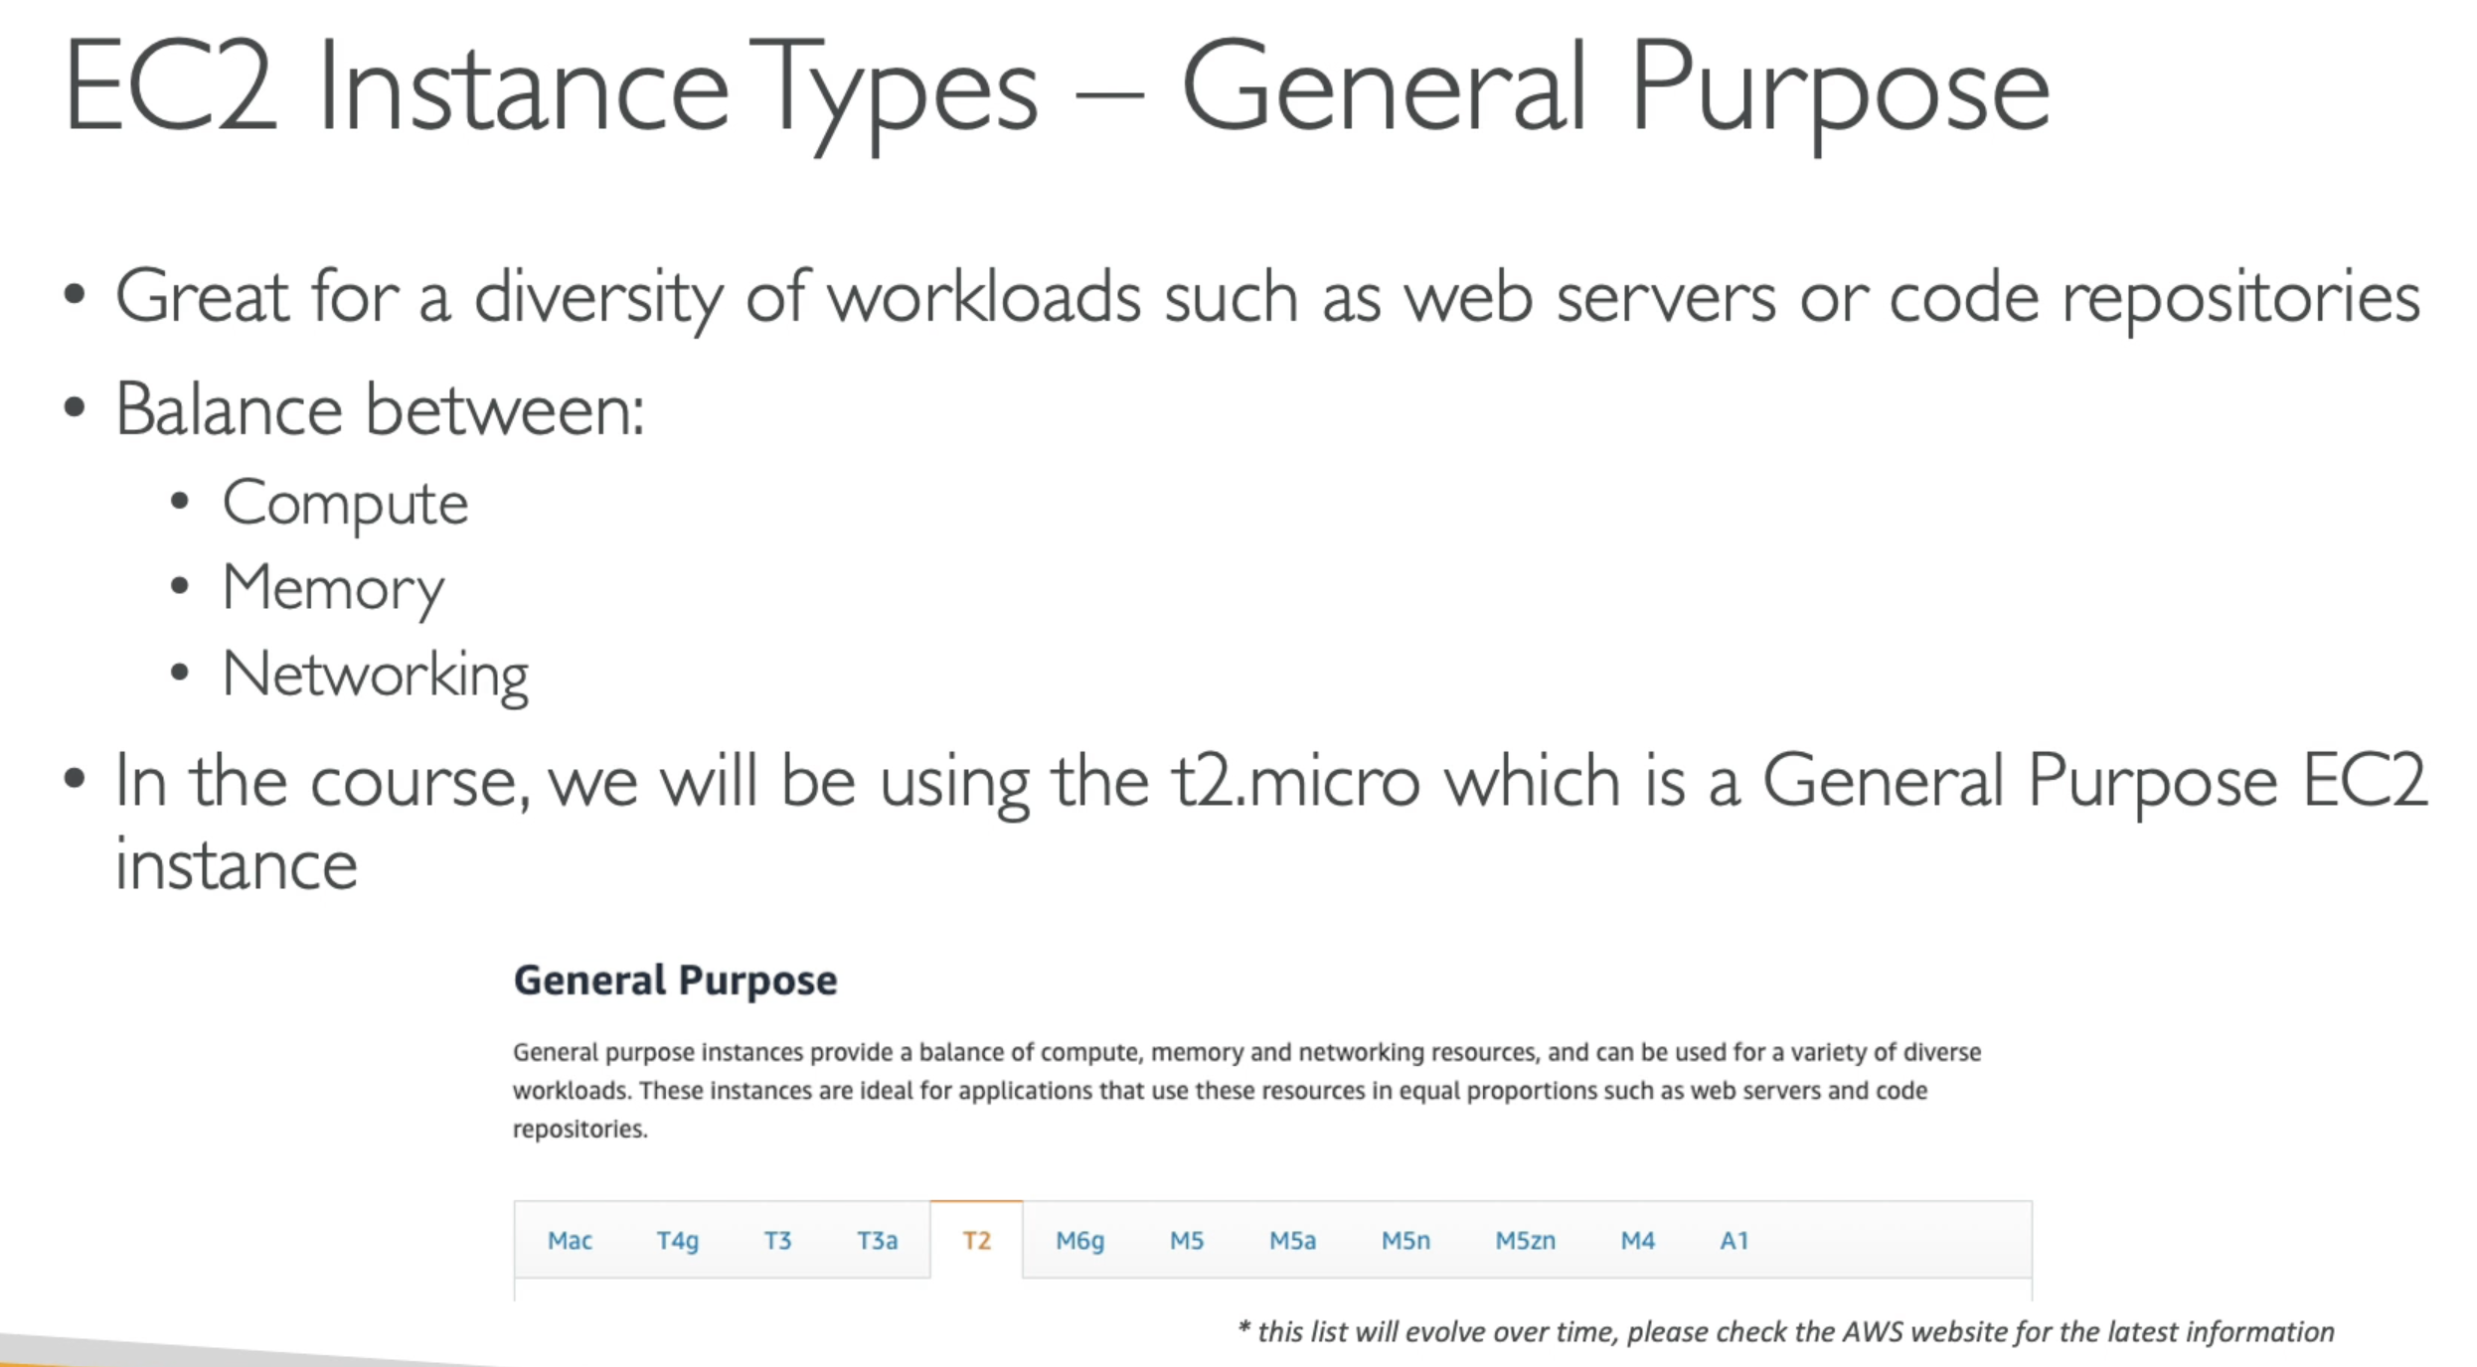

### Compute Optimized

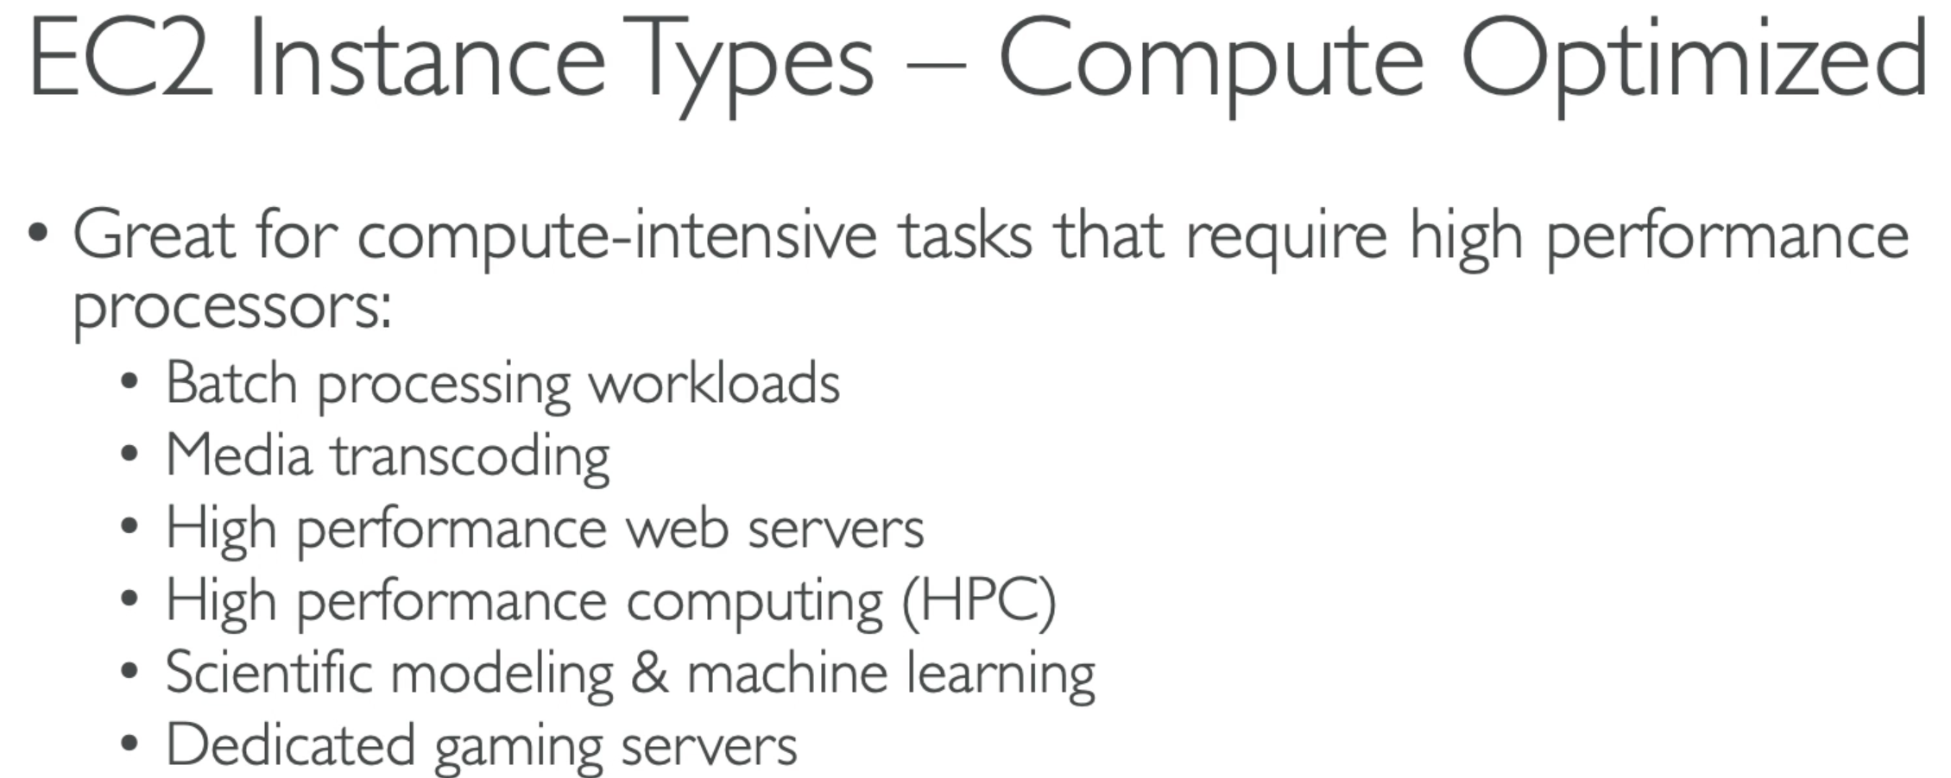

### Memory Optimized

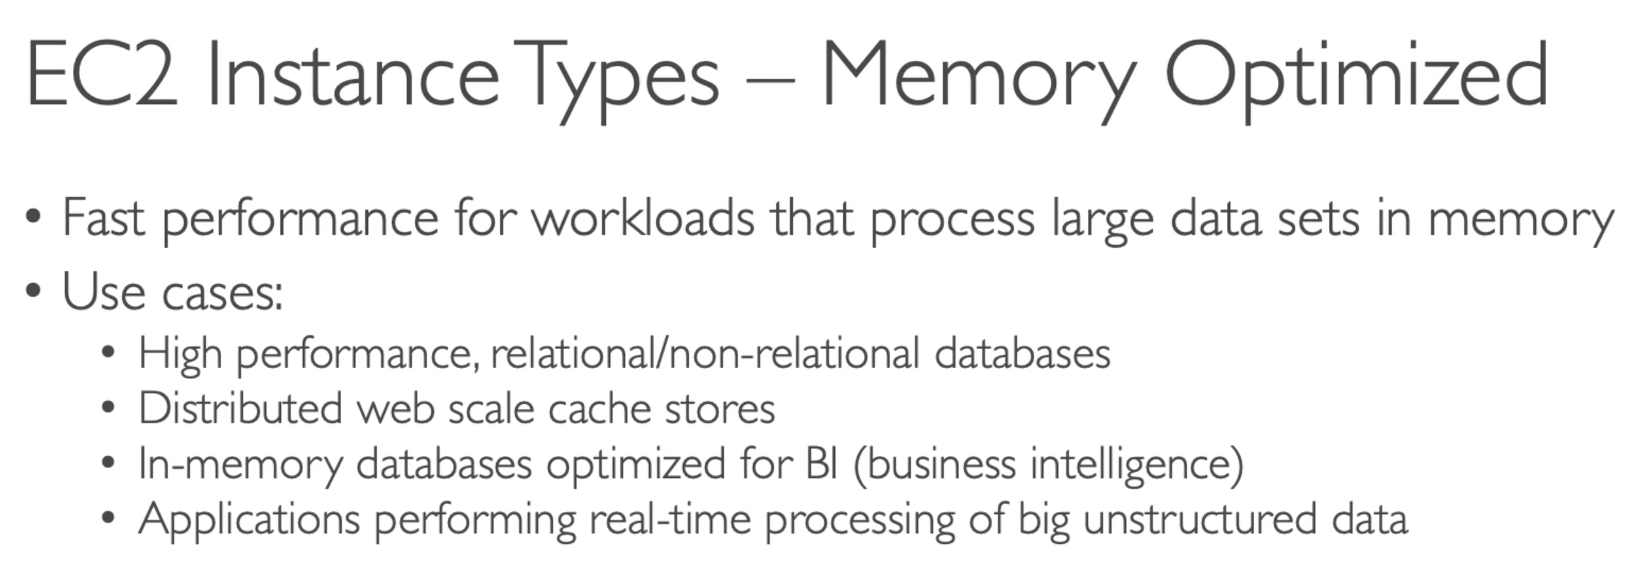

### Storage Optimized

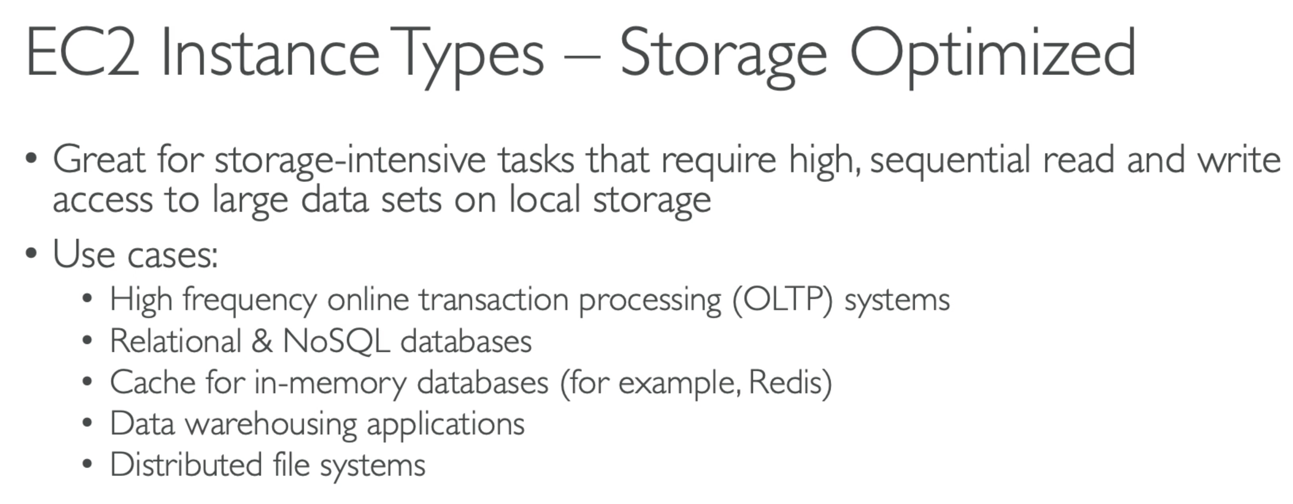

## 33. Security Groups & Classic Ports

* SG is locked down to a region/VPC combination. If you create it in one region, you cannot access it from other region
* If your app is not accessible (time out) 🡪 it’s a SG issue
* If your app gives a ‘connection refused’ error 🡪 it’s an application error or it is not launched.
* All in bound traffic is blocked by default
* All out bound traffic is allowed by default

### Classic Ports

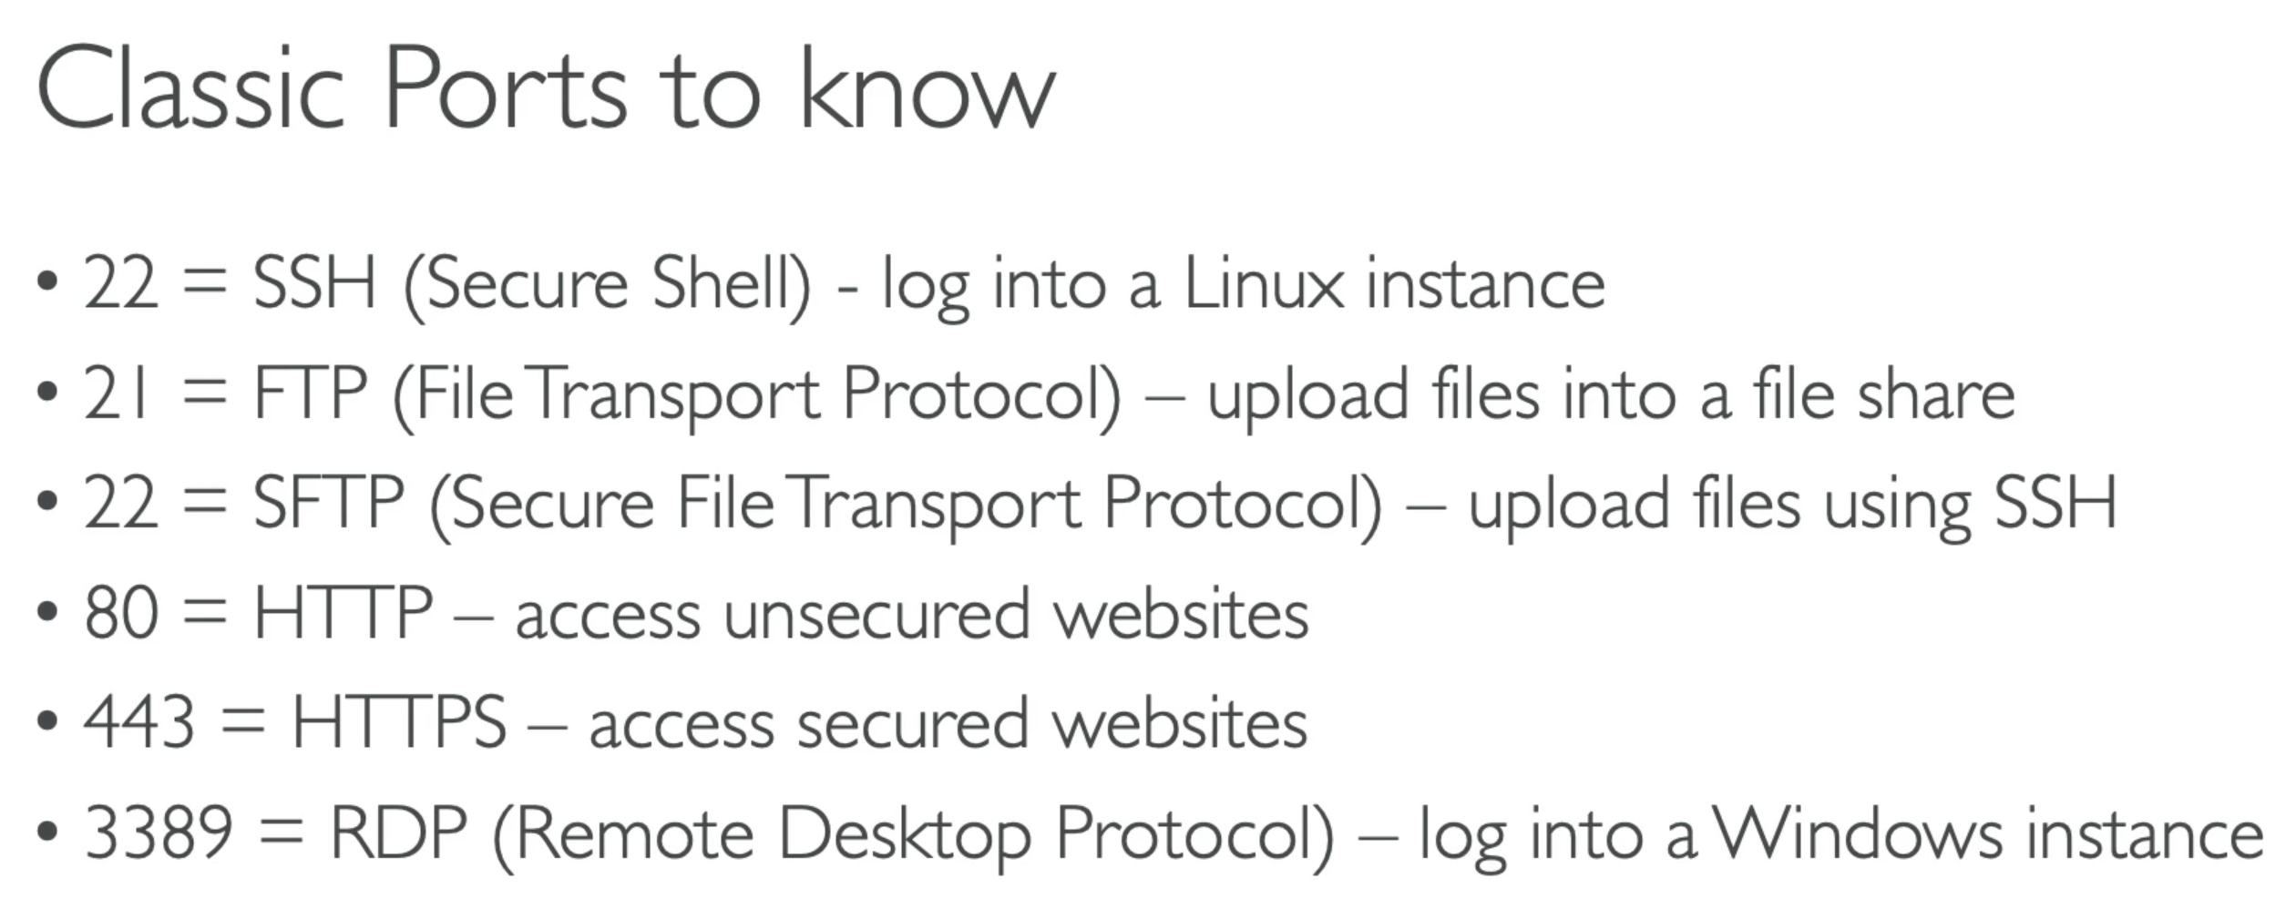

## 35. SSH Overview

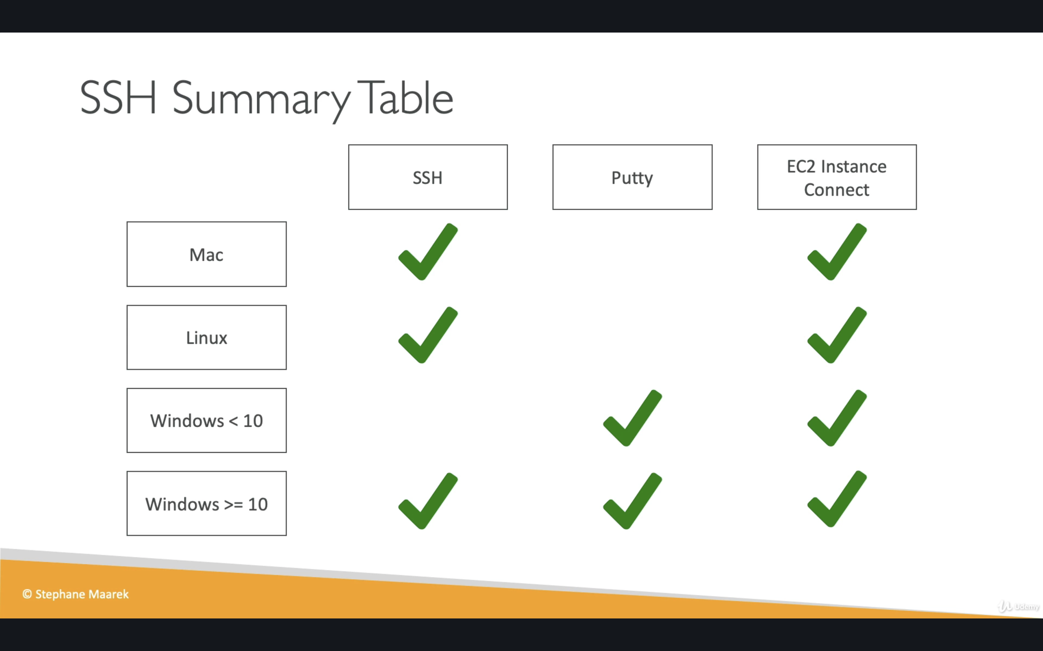

## 42. EC2 Instance Launch Types

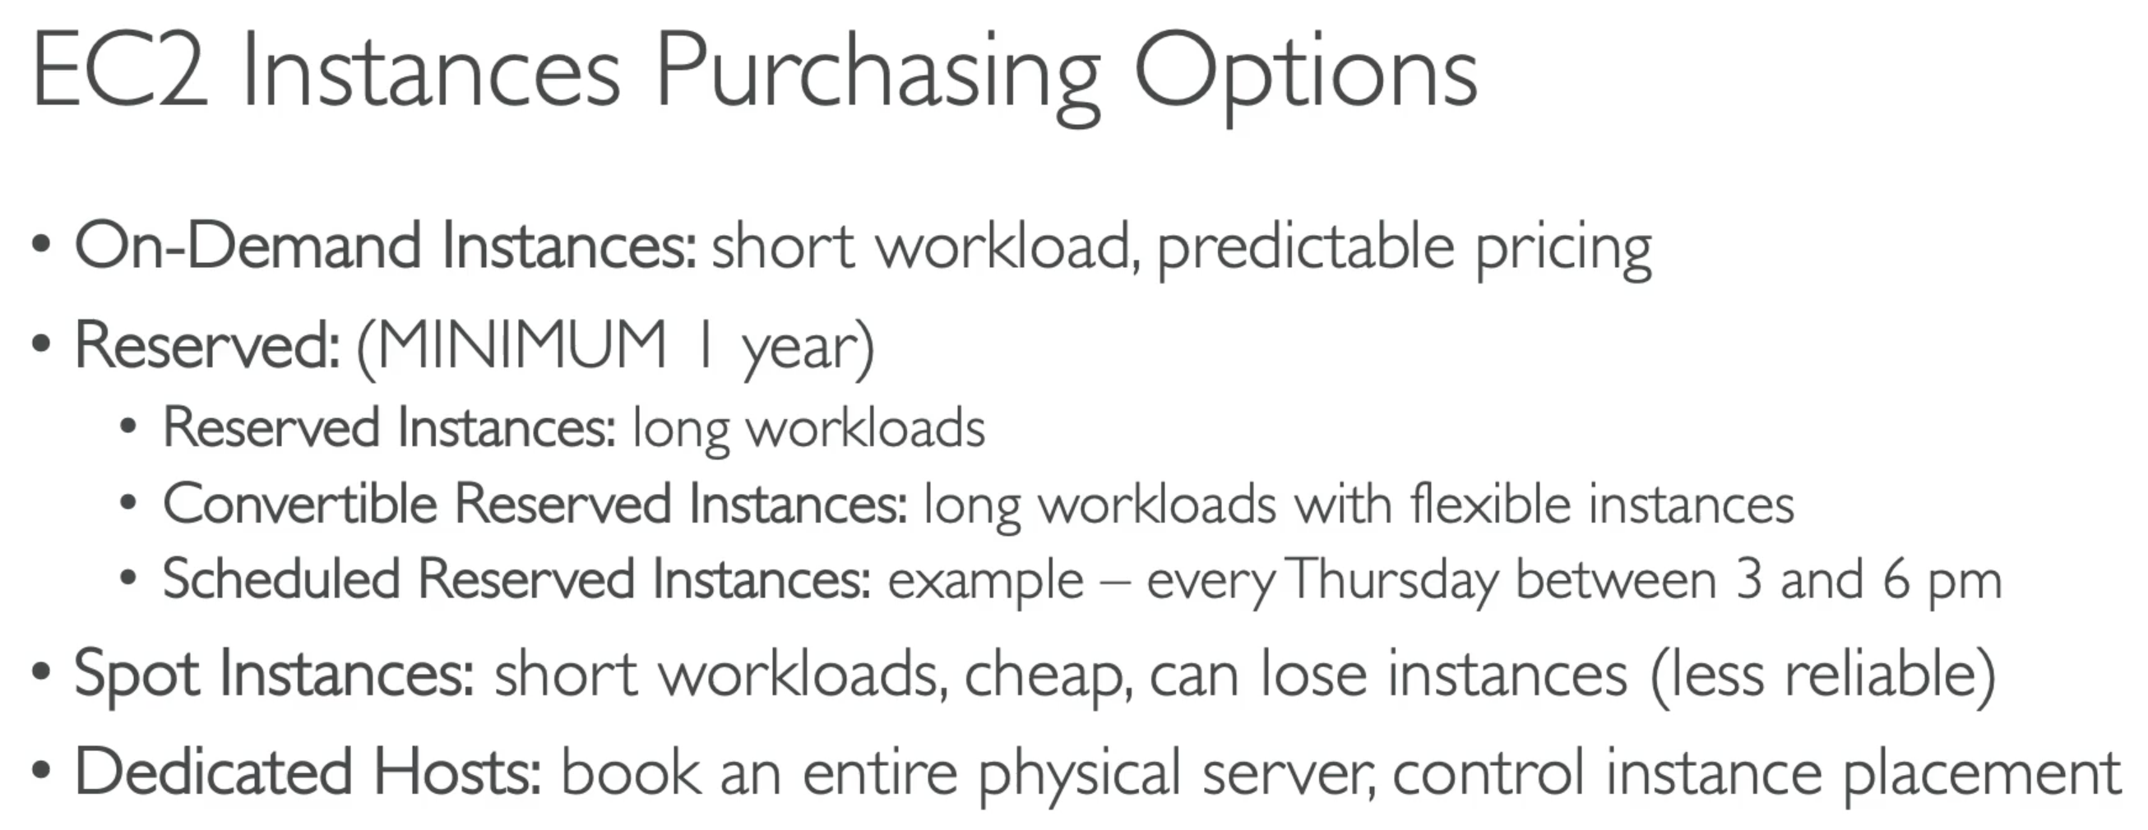

### On Demand

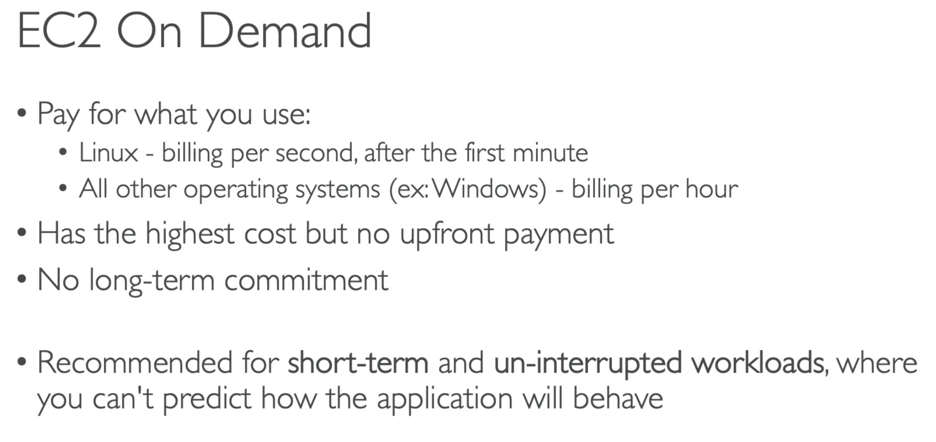

### Reserved Instances

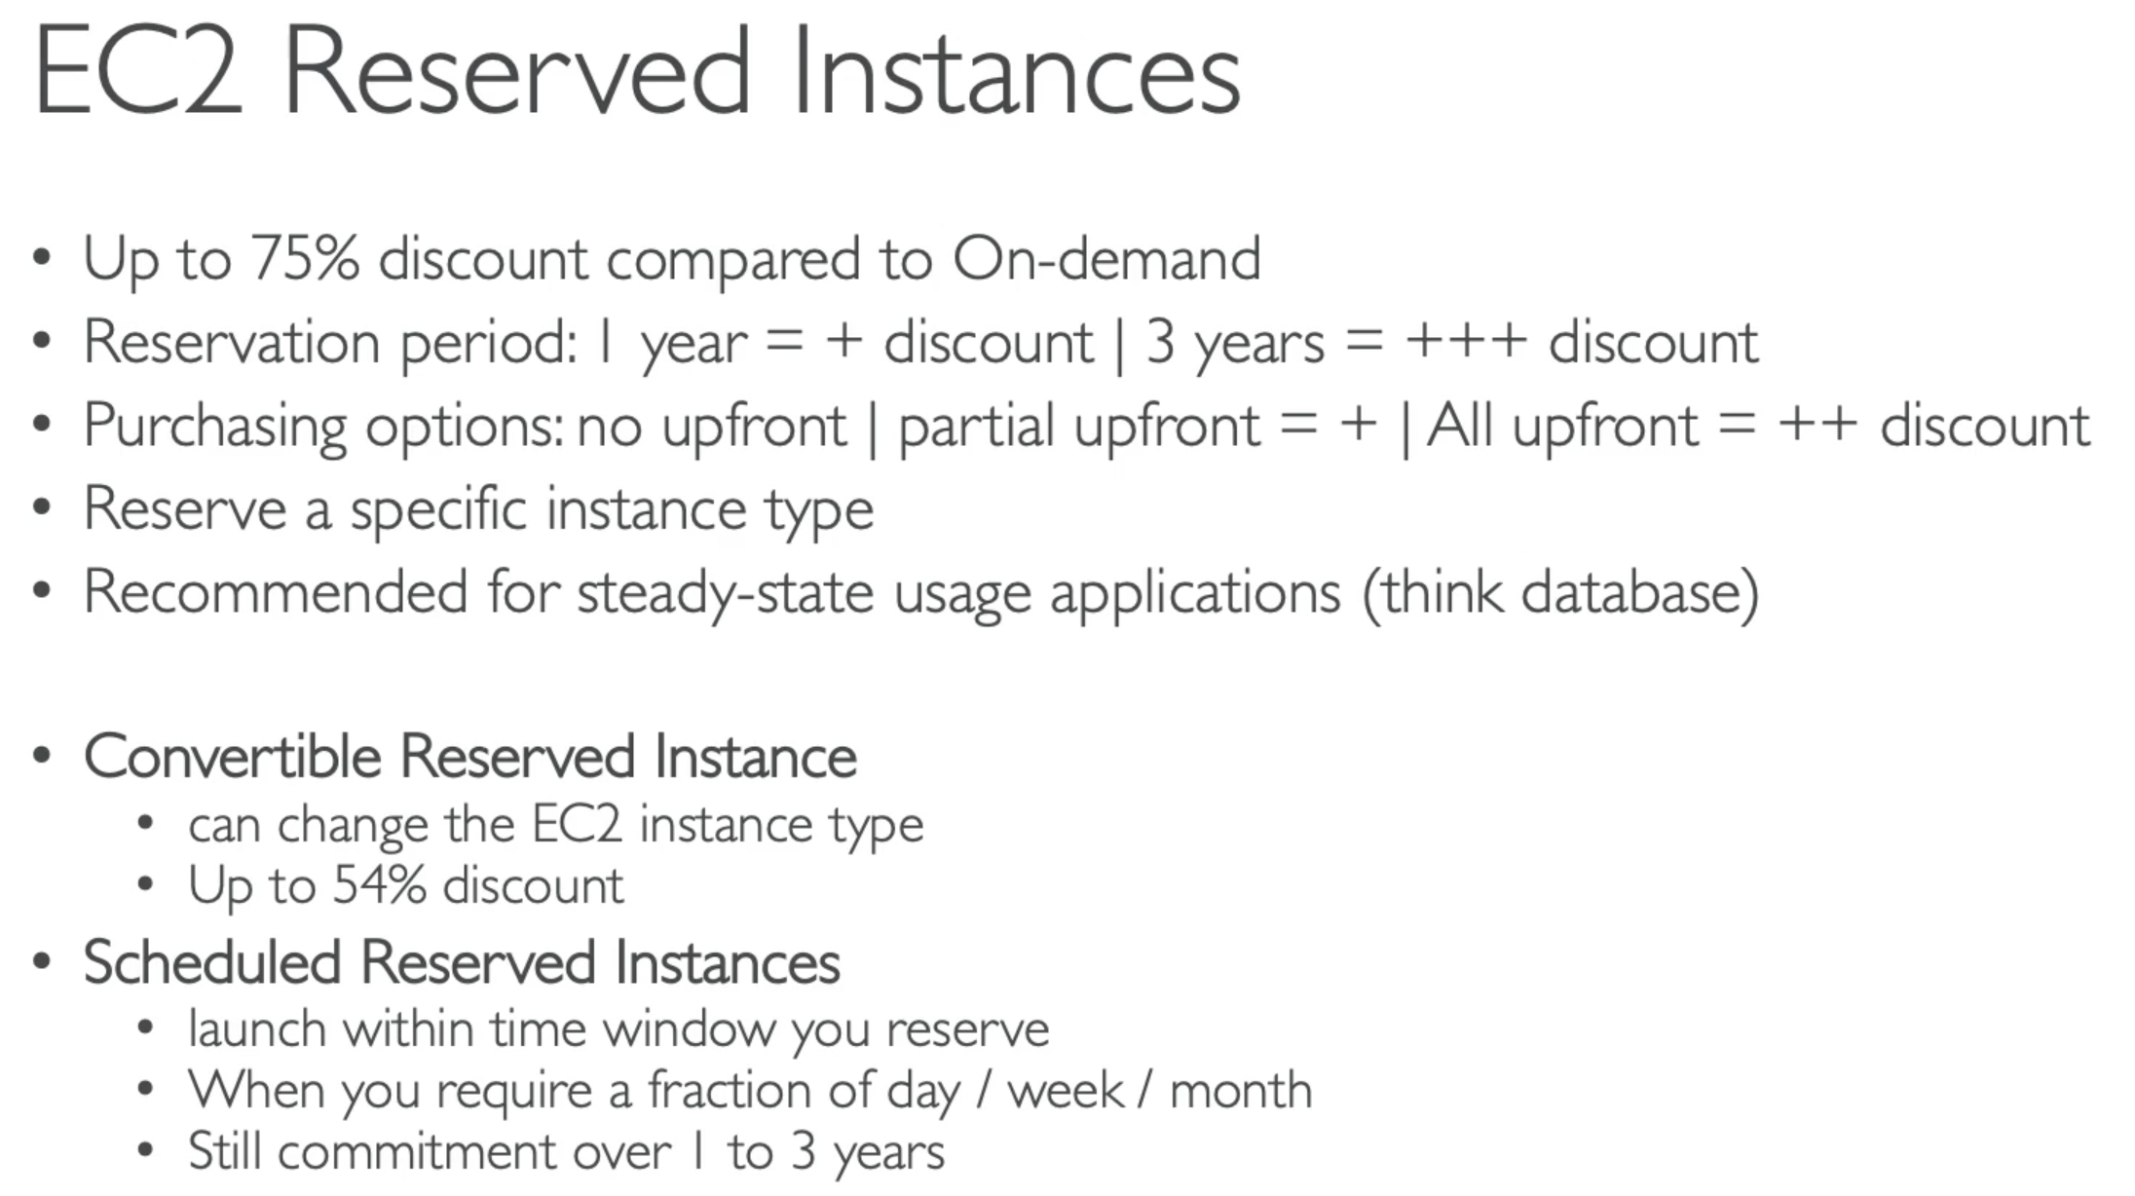

### Spot Instances

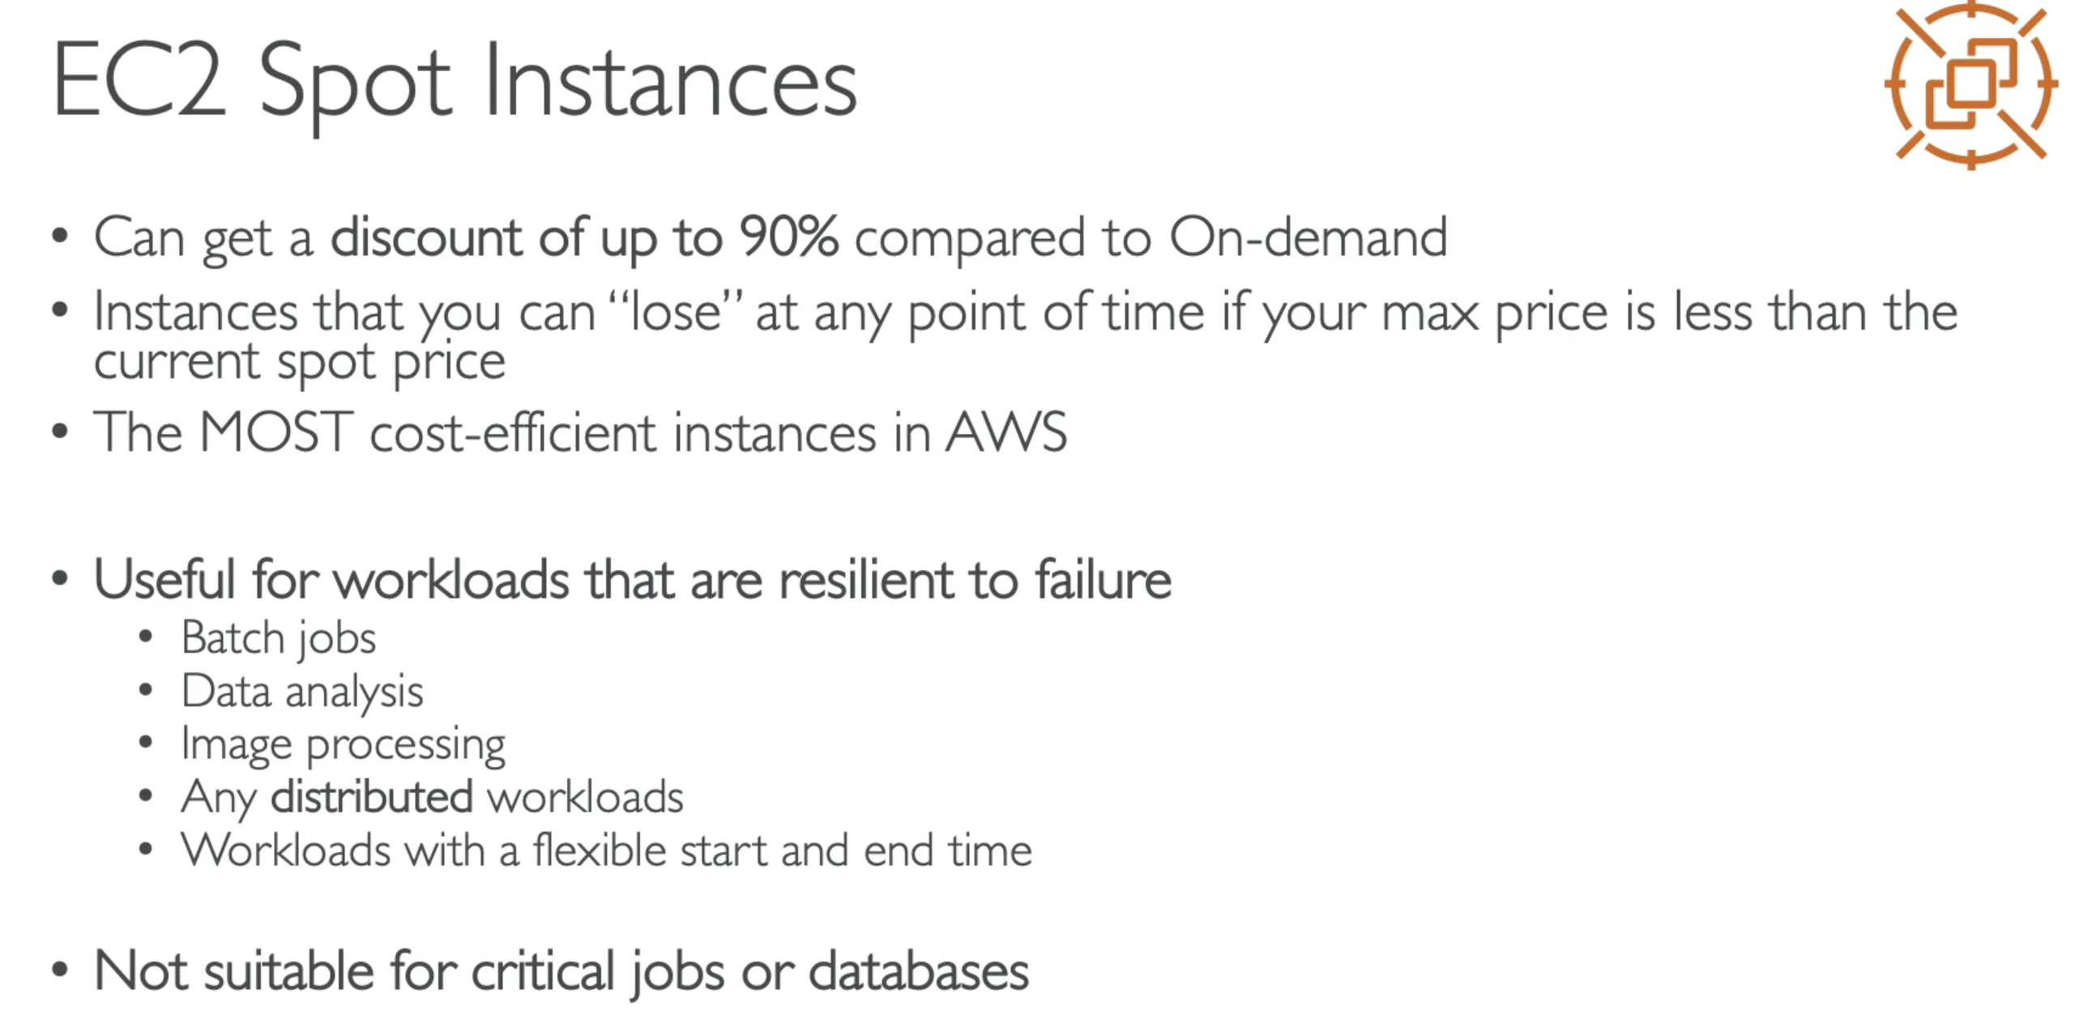

### Dedicated Hosts

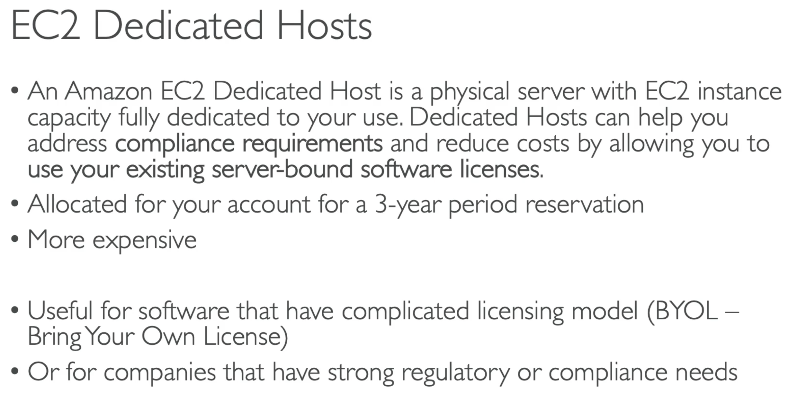

### Dedicated Instance

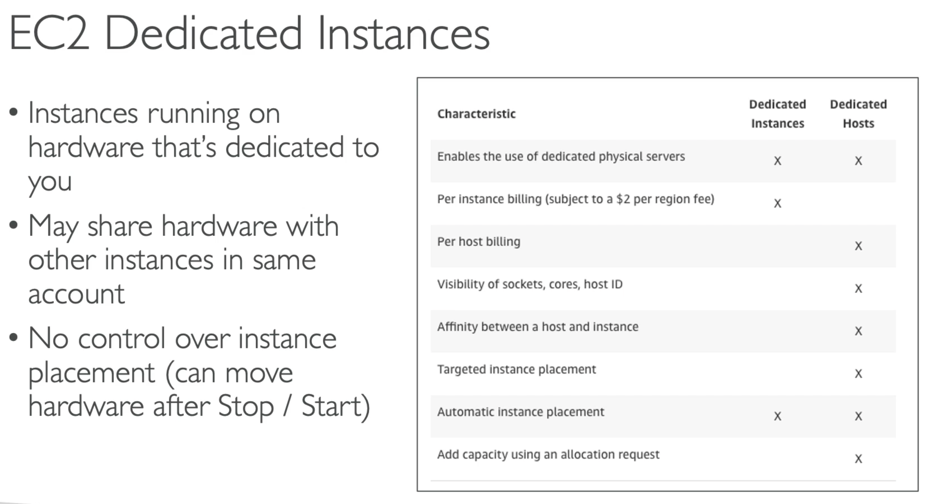

# Section 6: EC2 – Solution Architect Associate Level

## 43. Private vs Public vs Elastic IP

* With public IP you are accessible over internet
* With private IP you can be accessed only within your private network

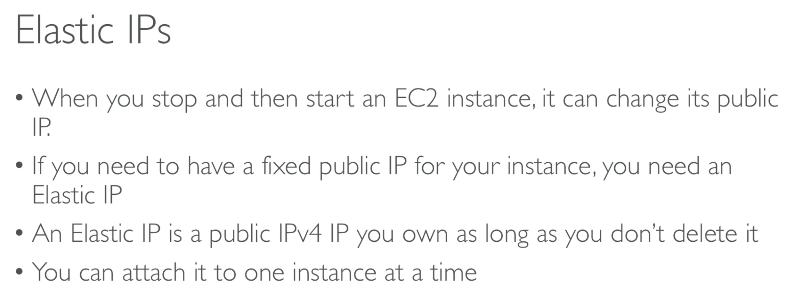

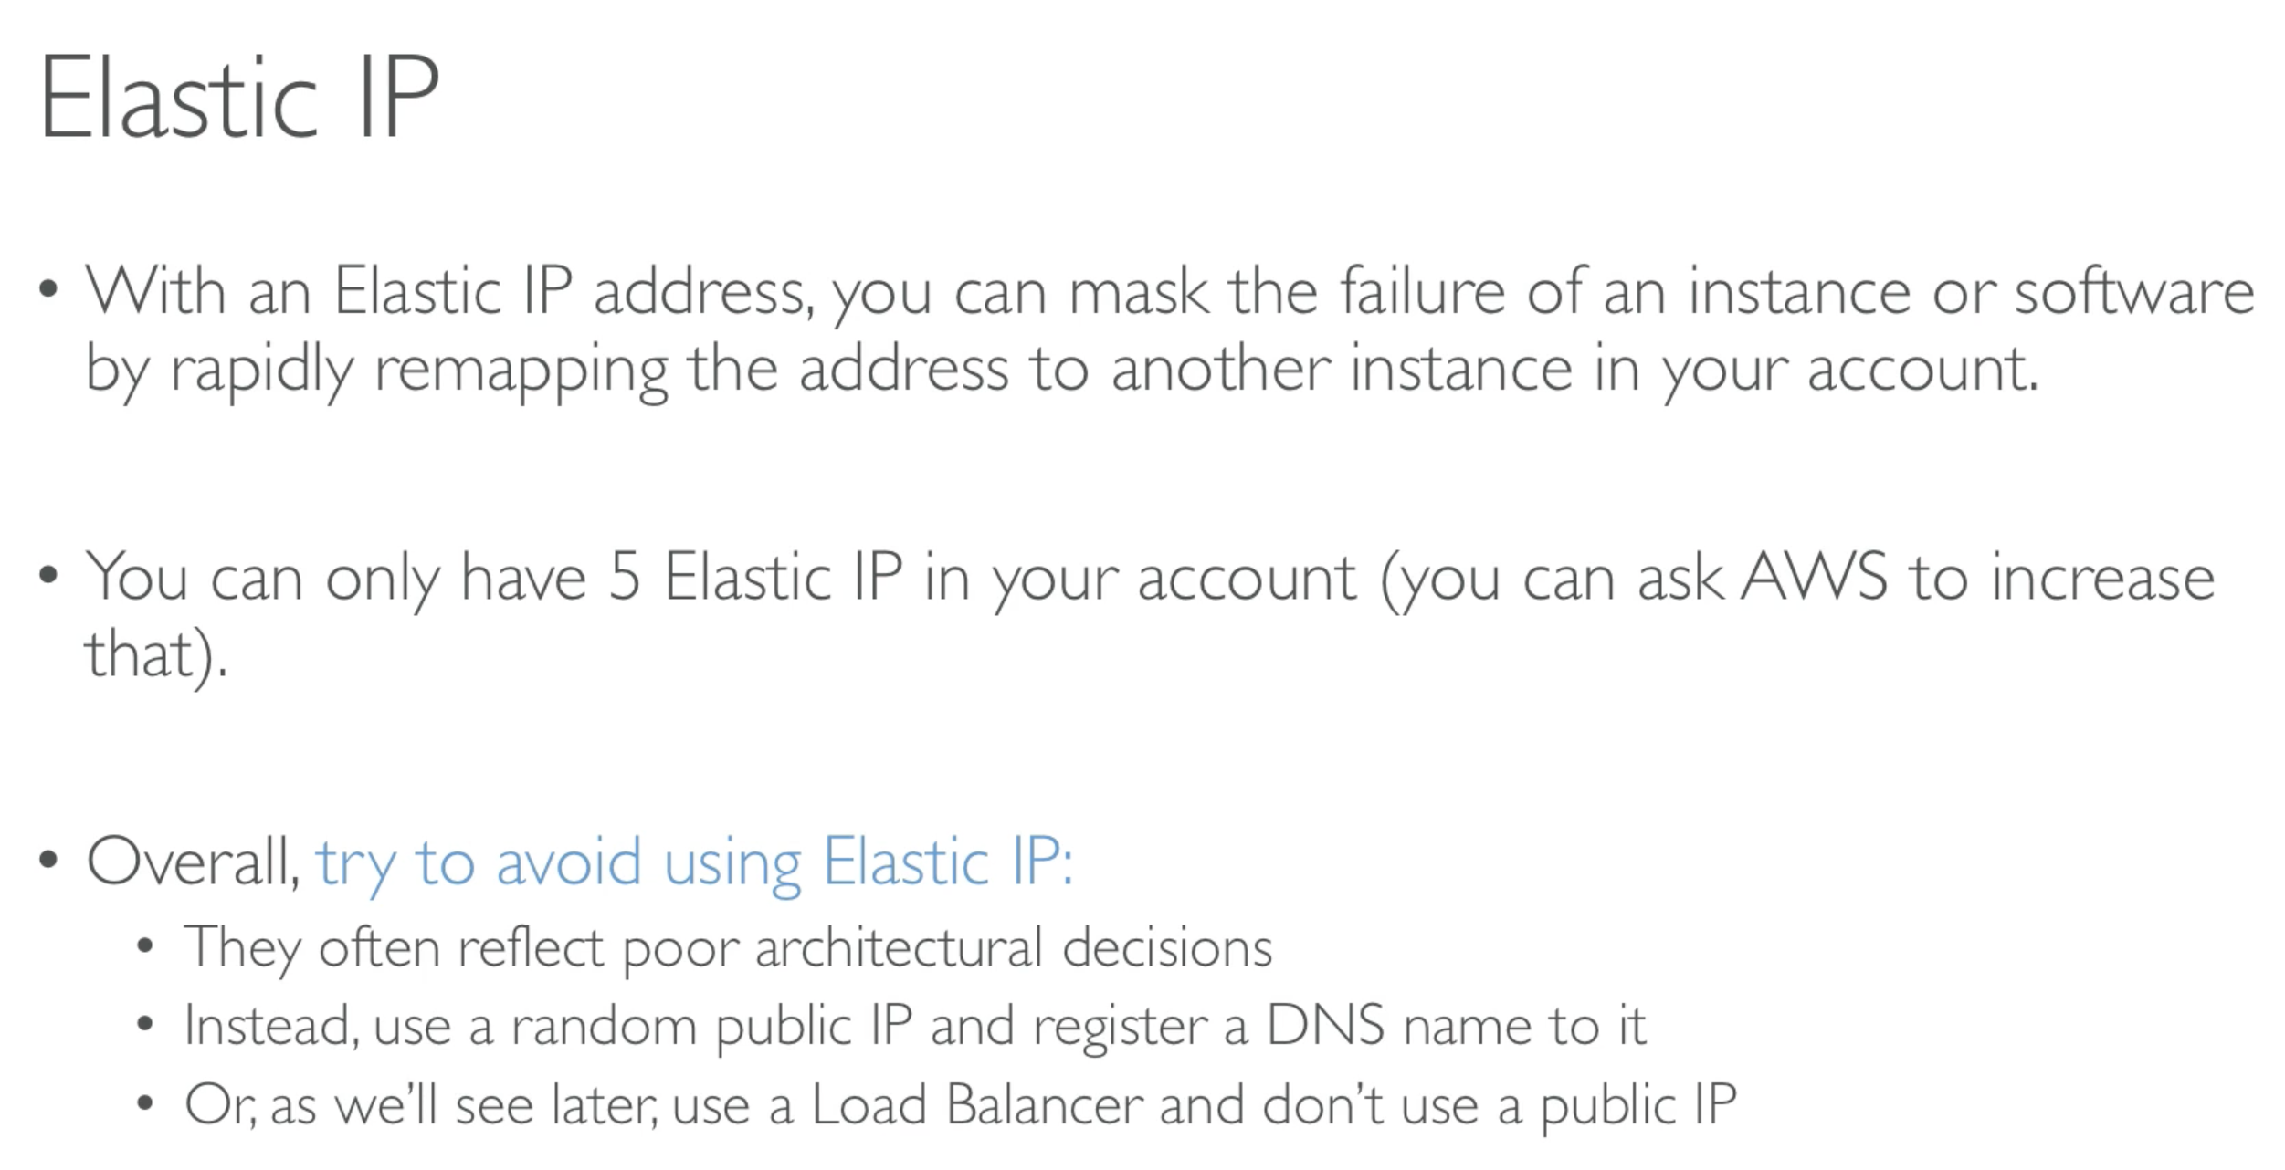

## 45. Spot Instances and Spot Fleet

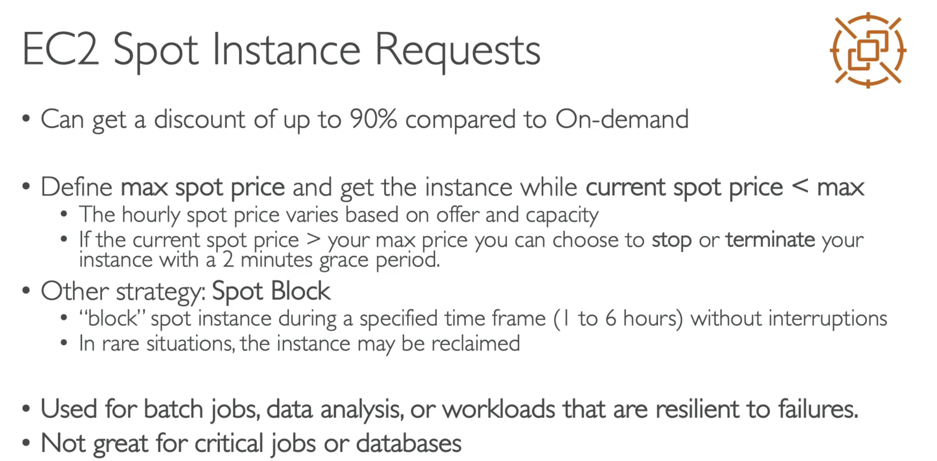

### **Terminate Spot Instances

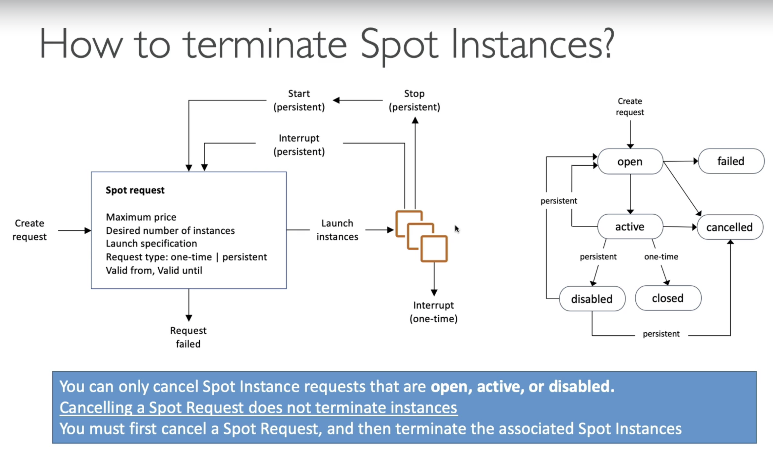

### Spot Fleet

Using spot fleet we can define multiple launch pool,

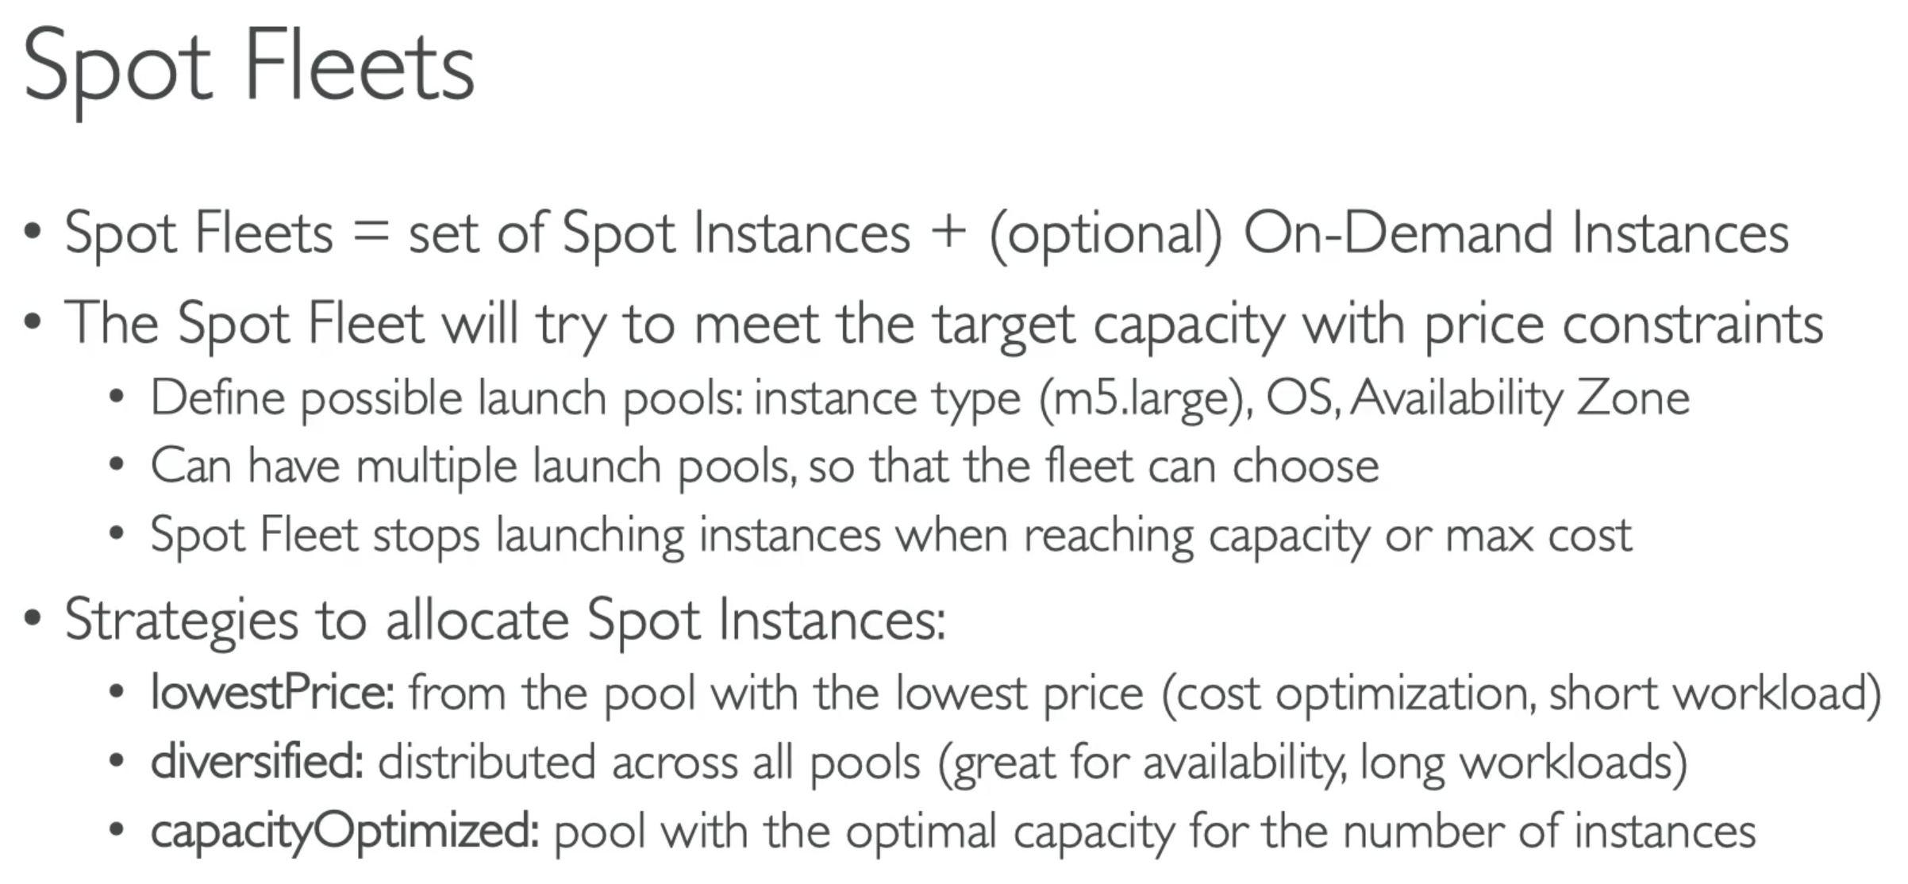

## 46. EC2 Placement Groups

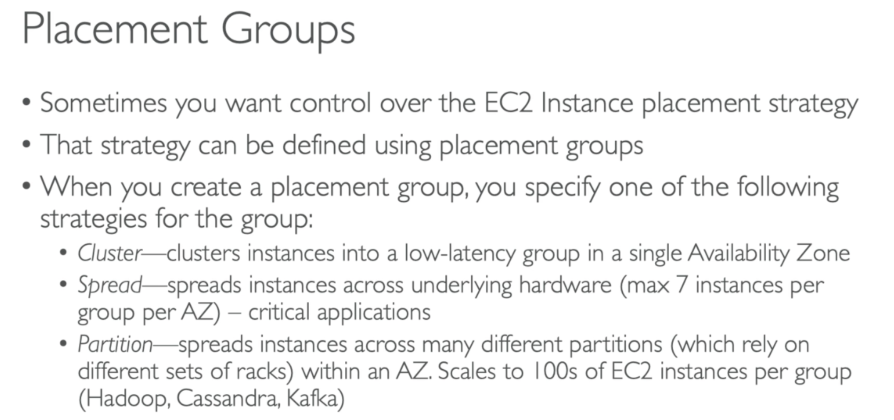

### Cluster Placement Group

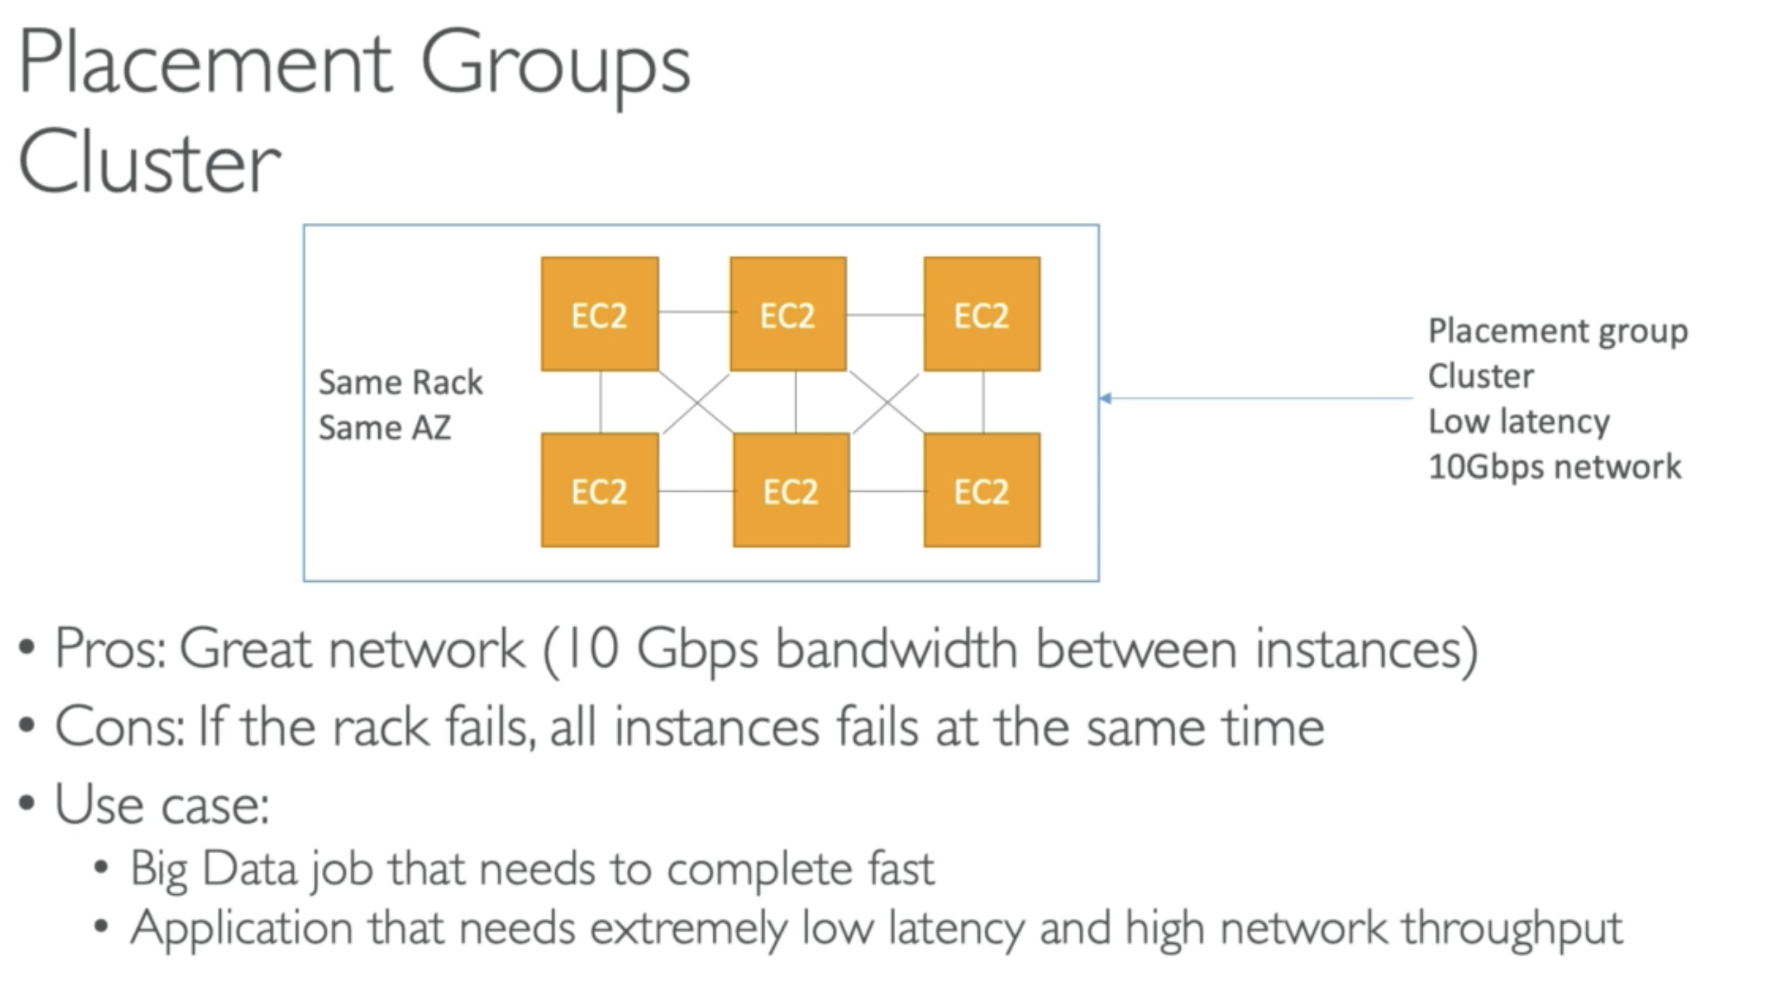

### Spread Placement Group

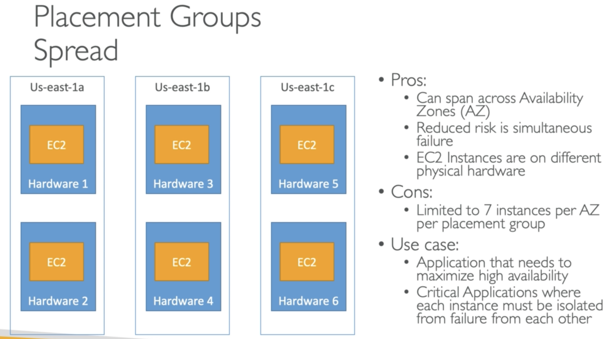

### Partition Placement Group

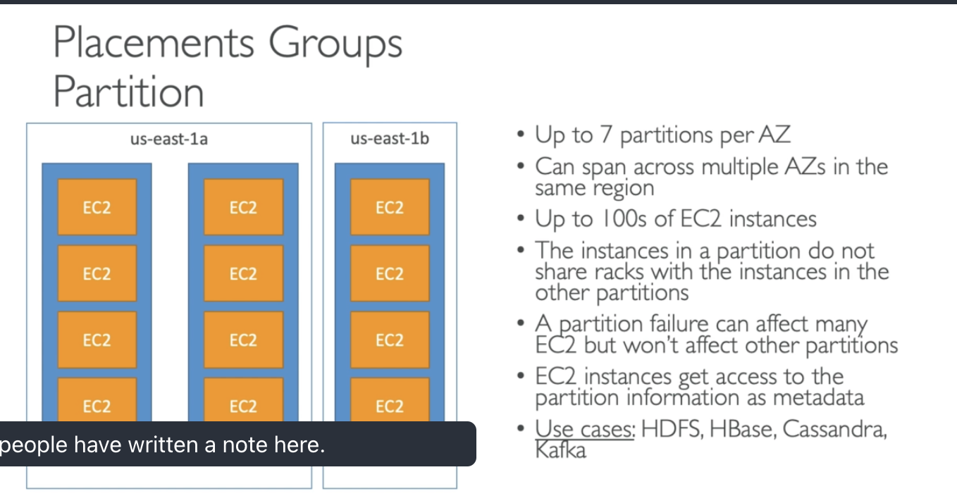

## 48. Elastic Network Interface – ENI

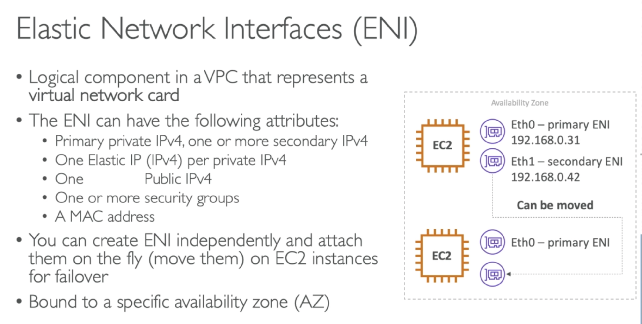

ENI is bound to AZ, however we can move Eth1(private IP) from one instance to another within the same AZ. It is very helpful for failovers, if you instance is accessed by a private static IP, you can move it around to EC2 instances for failover purposes.

## 50. ENI – Blog

<https://aws.amazon.com/blogs/aws/new-elastic-network-interfaces-in-the-virtual-private-cloud/>

## 51. EC2 Hibernate

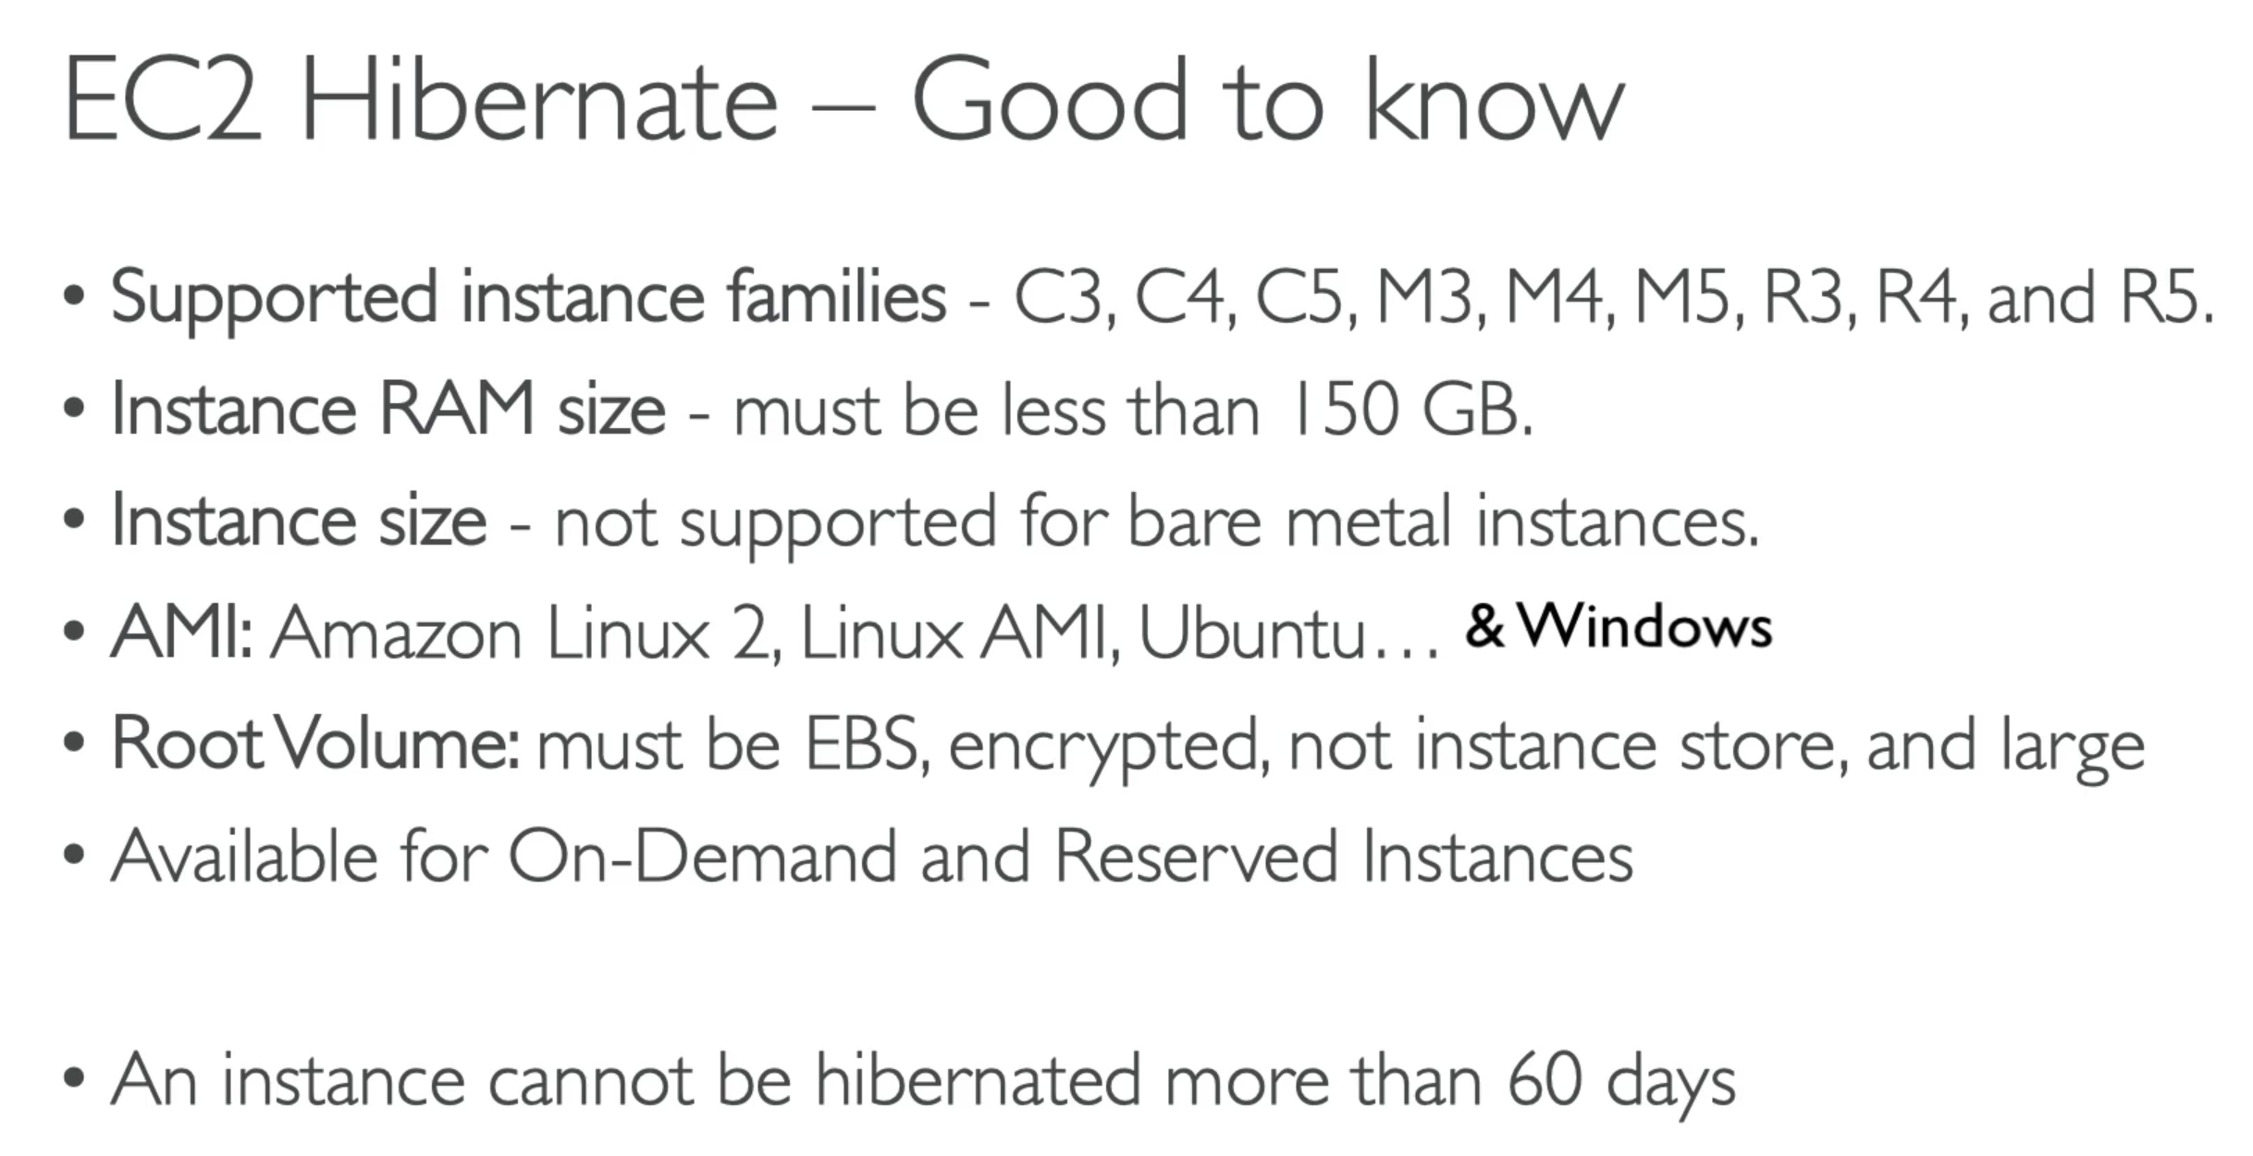

This slide is not imp for exam

## 53. EC2 – Advanced Concept (Nitro, vCPU, Capacity Reservations)

### EC2 Nitro

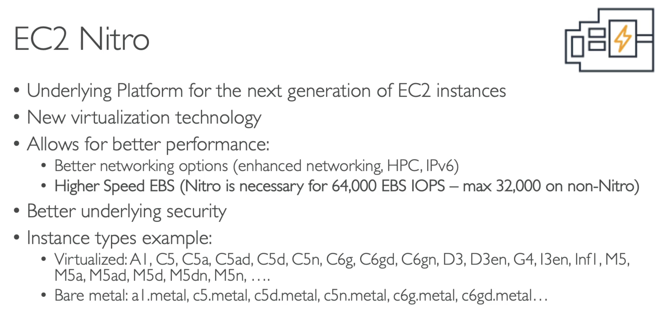

ExamTip:

* New Virtualisation technology; underlying platform for the next generation of EC2 instances
* Nitro is needed for higher speed EBS volumes to make sure you are leveraging increased speed of IOPs.

### vCPU

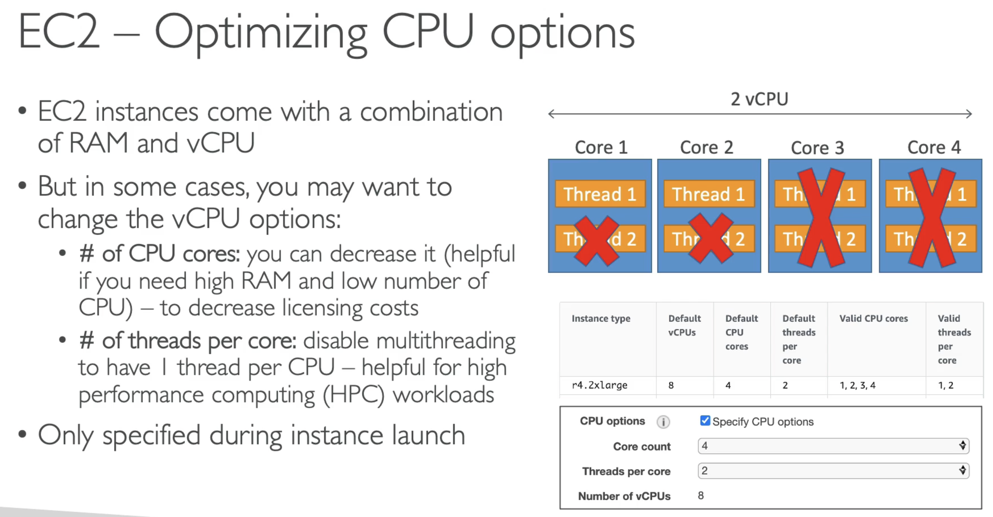

ExamTip: Remember you can optimise CPU options, and it may come up in the licencing cost questions.

### EC2 – Capacity Reservation

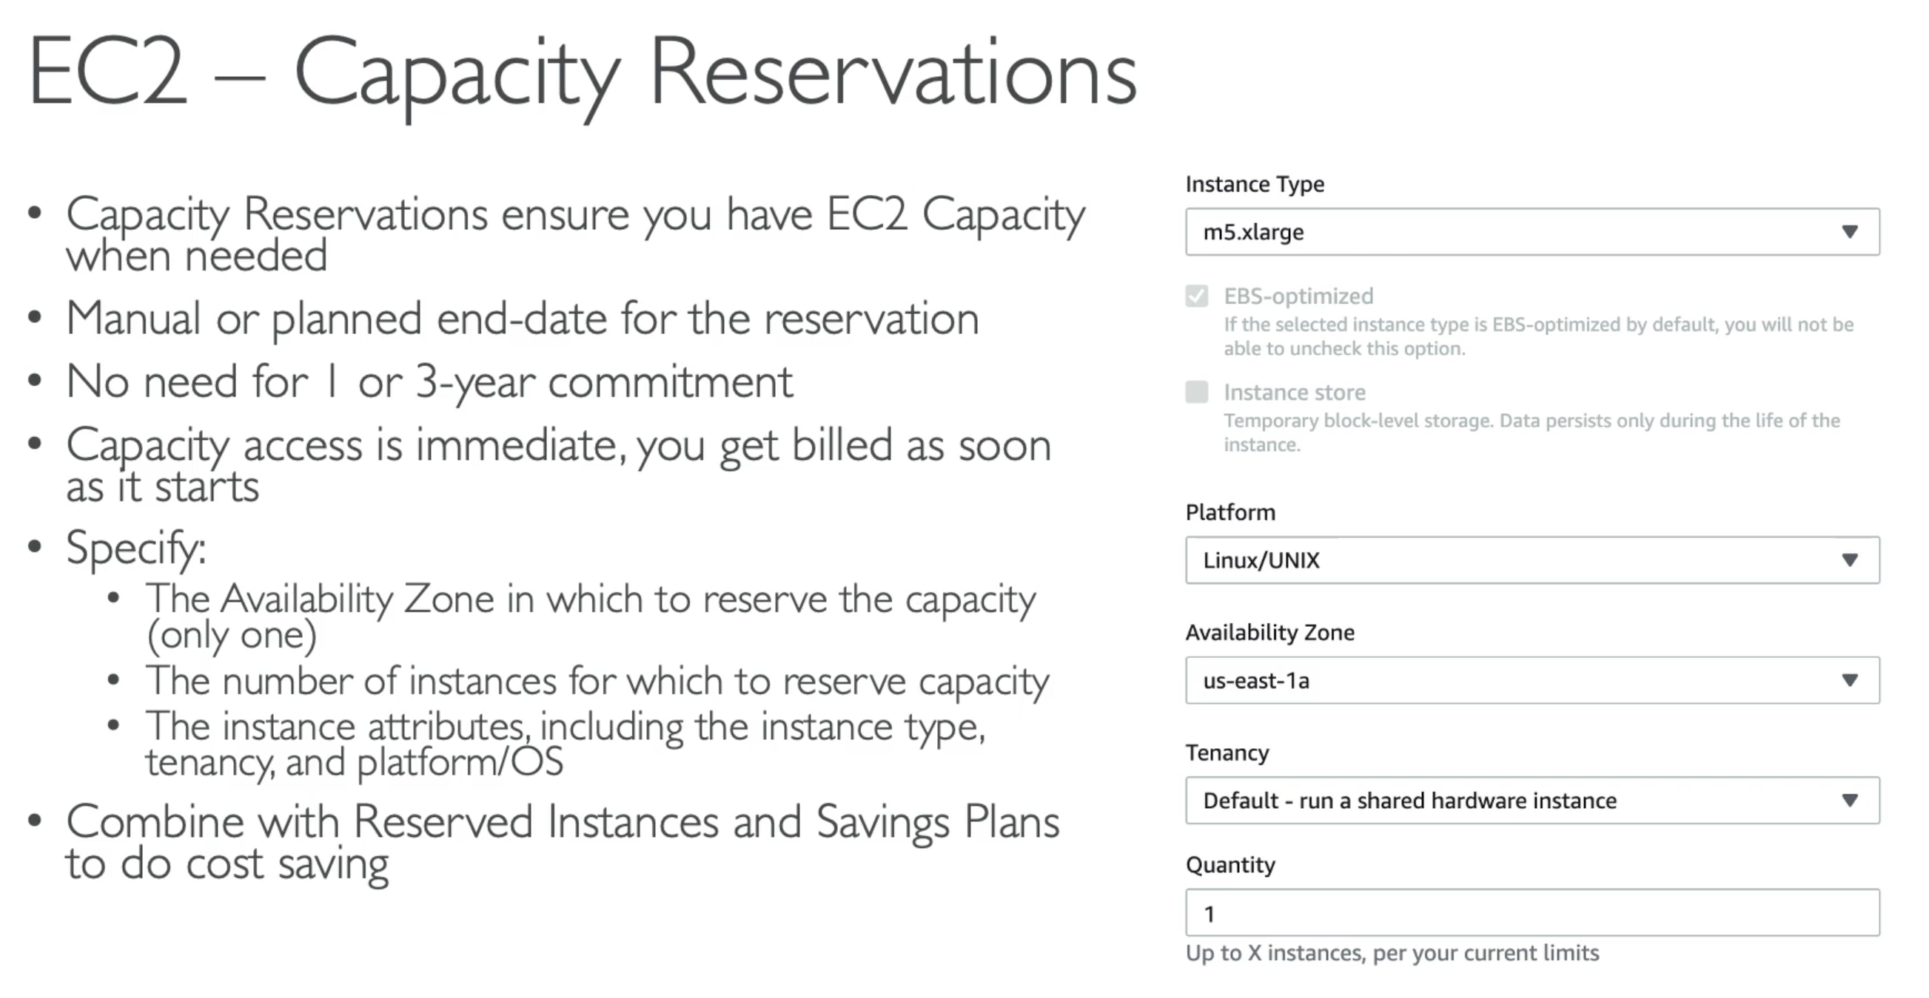

If you want to launch instances in AZ of specific type, around the specific time frame 🡪 use EC2 Capacity Reservation

# Section 7: EC2 Instance Storage

## 54. EBS Overview

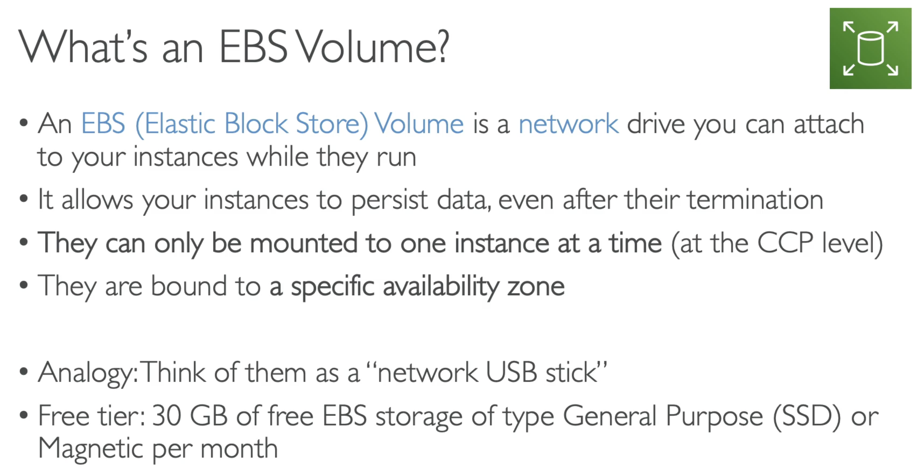

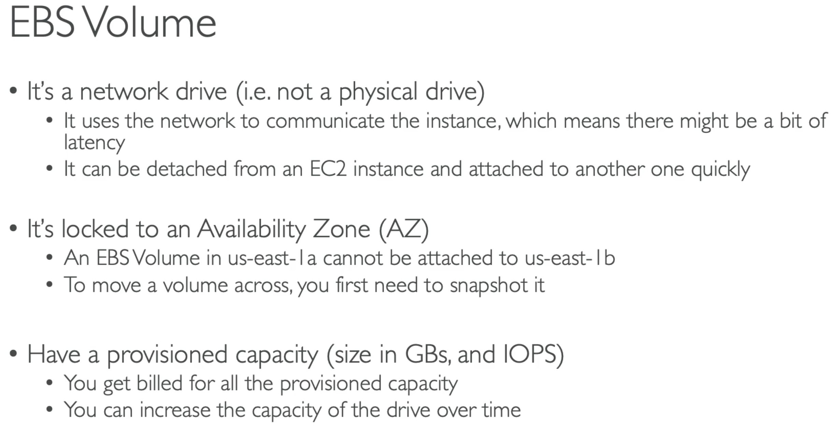

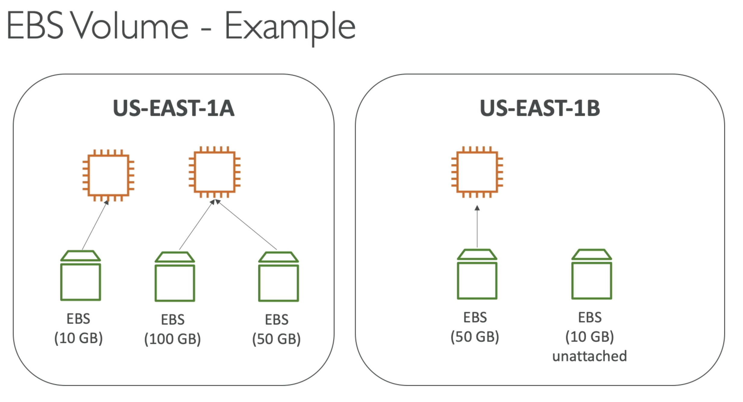

* We can create EBS volumes and leave them unattached. They can be attached on demand.

### **Delete on Termination attribute

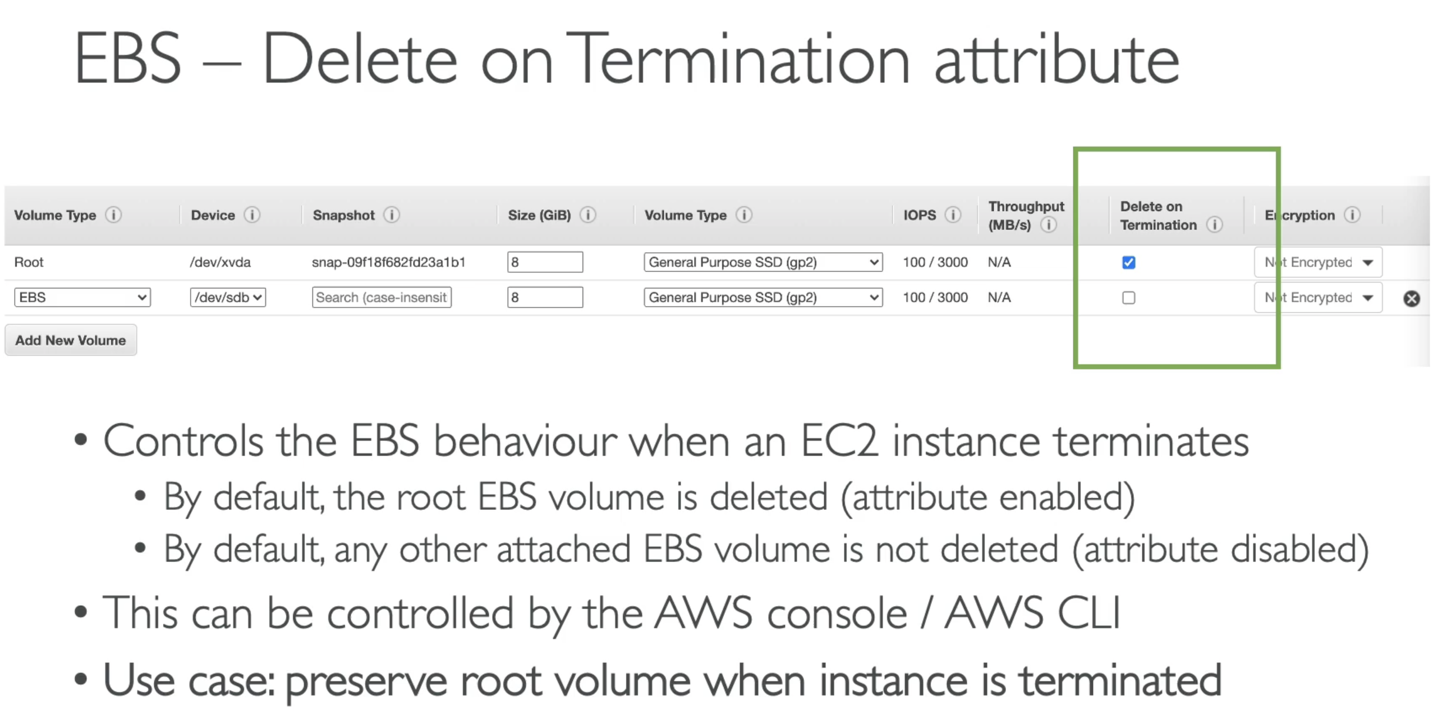

## 56. EBS Snapshot Overview

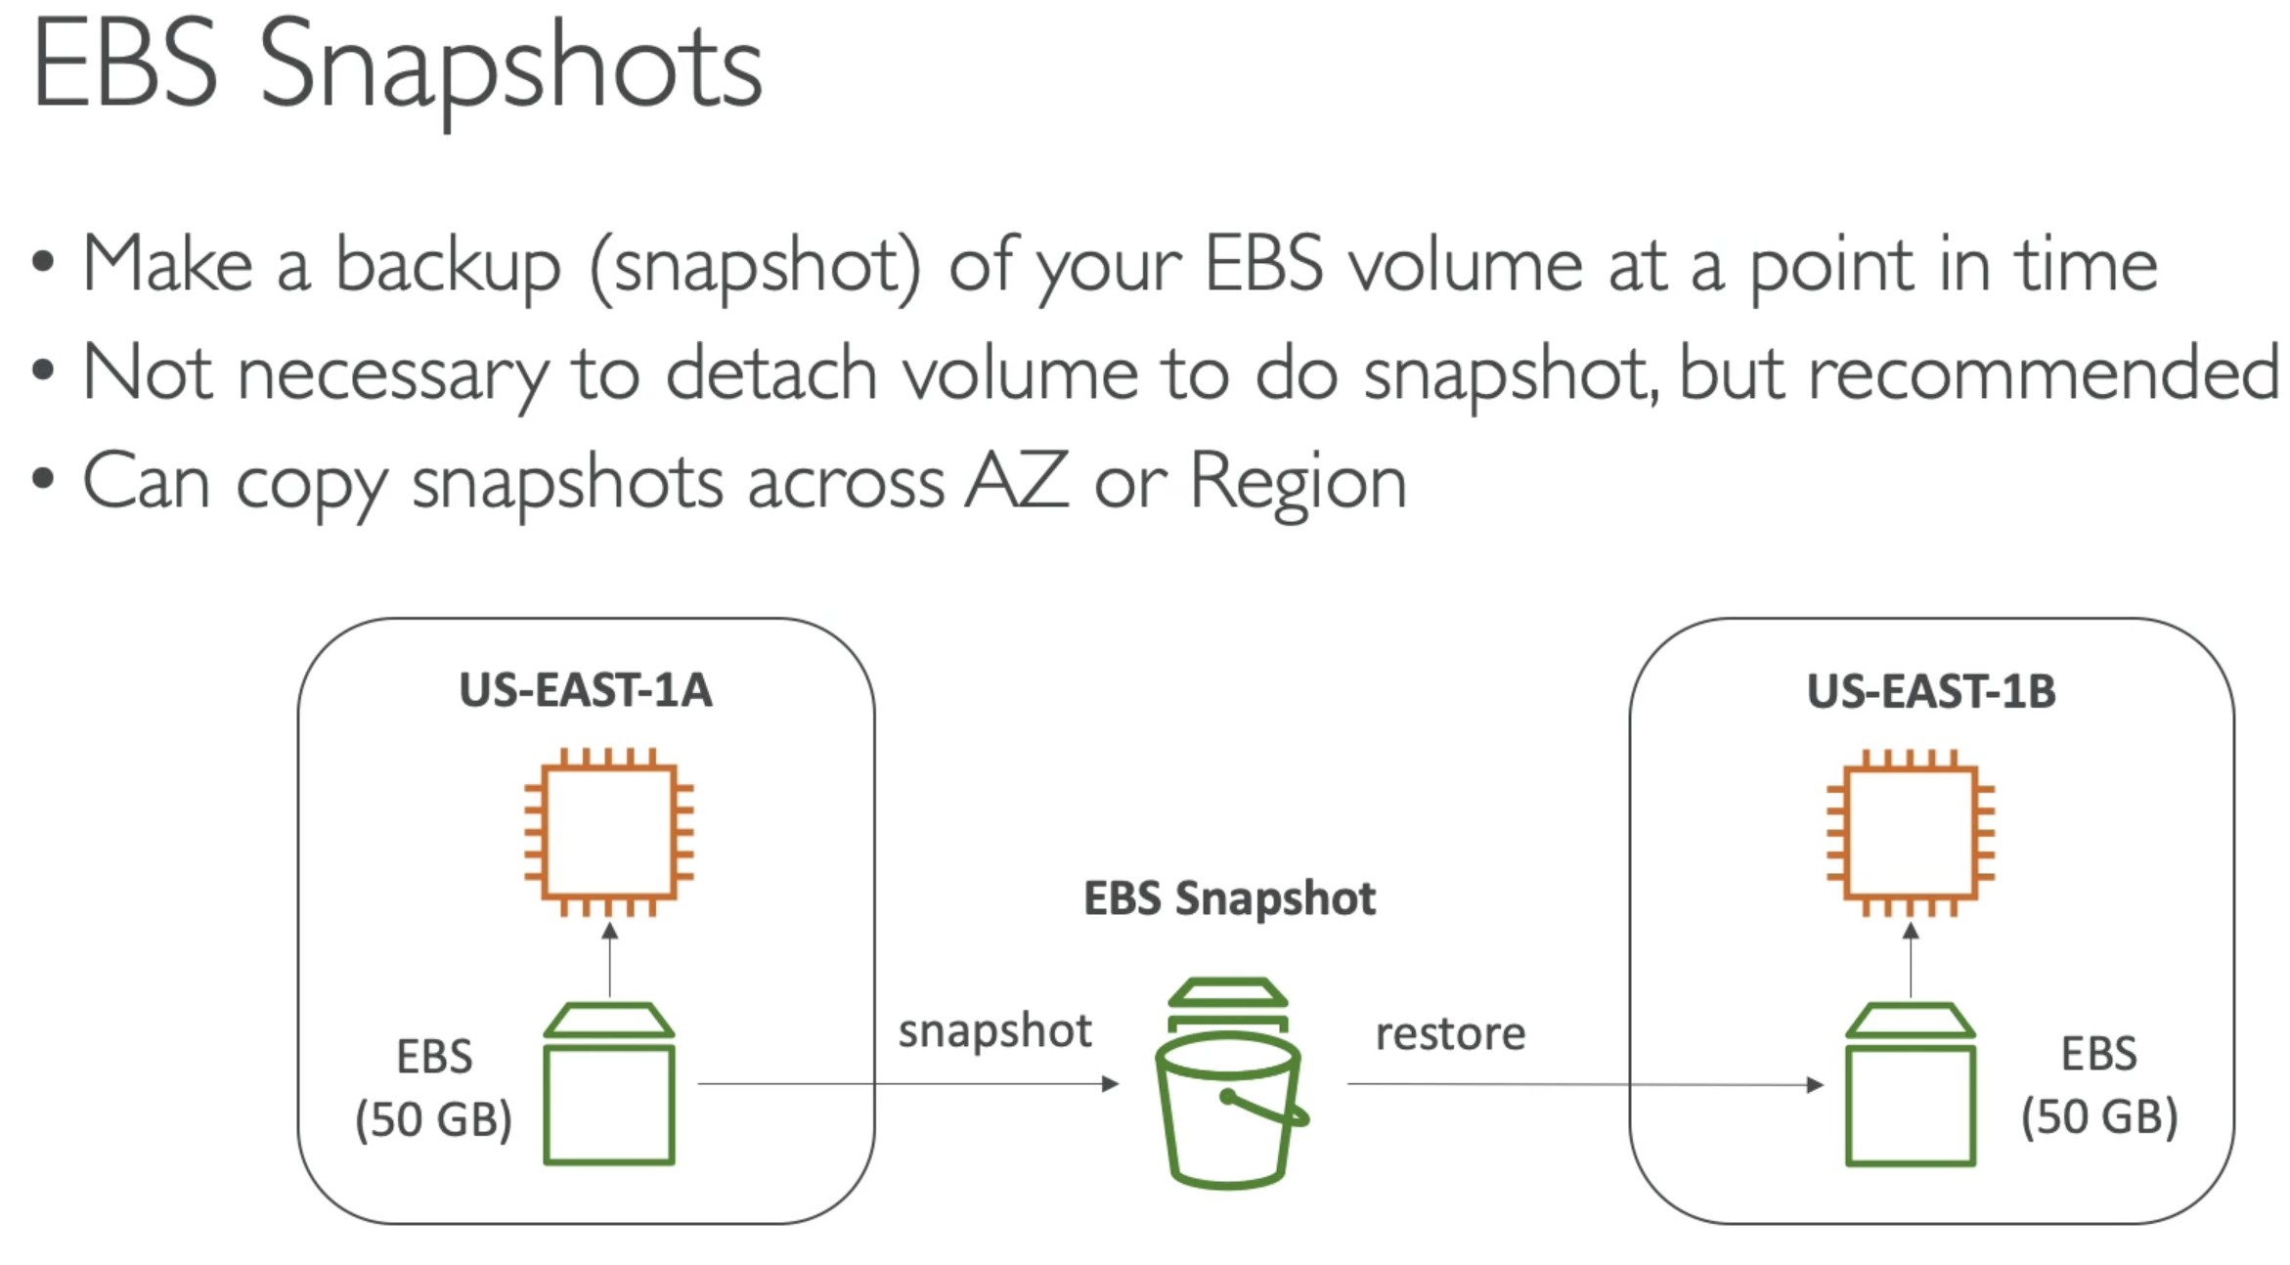

## 58. AMI Overview

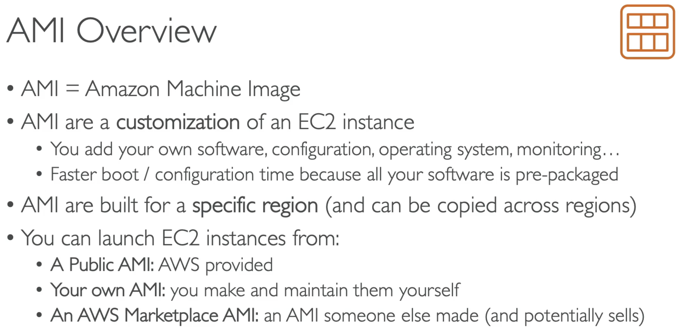

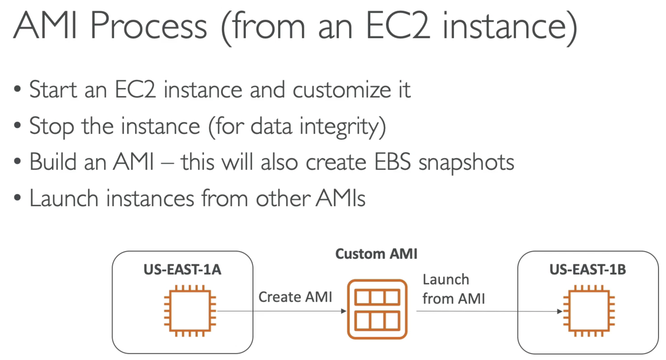

## 60. EC2 Instance Store

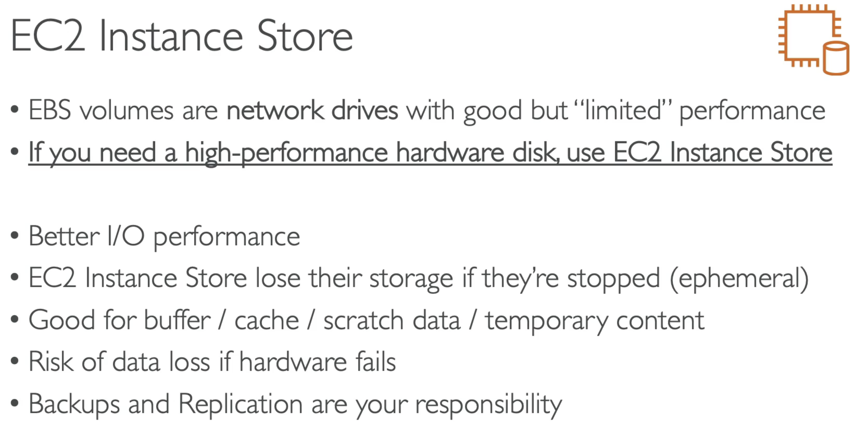

## 61. EBS Volume Types

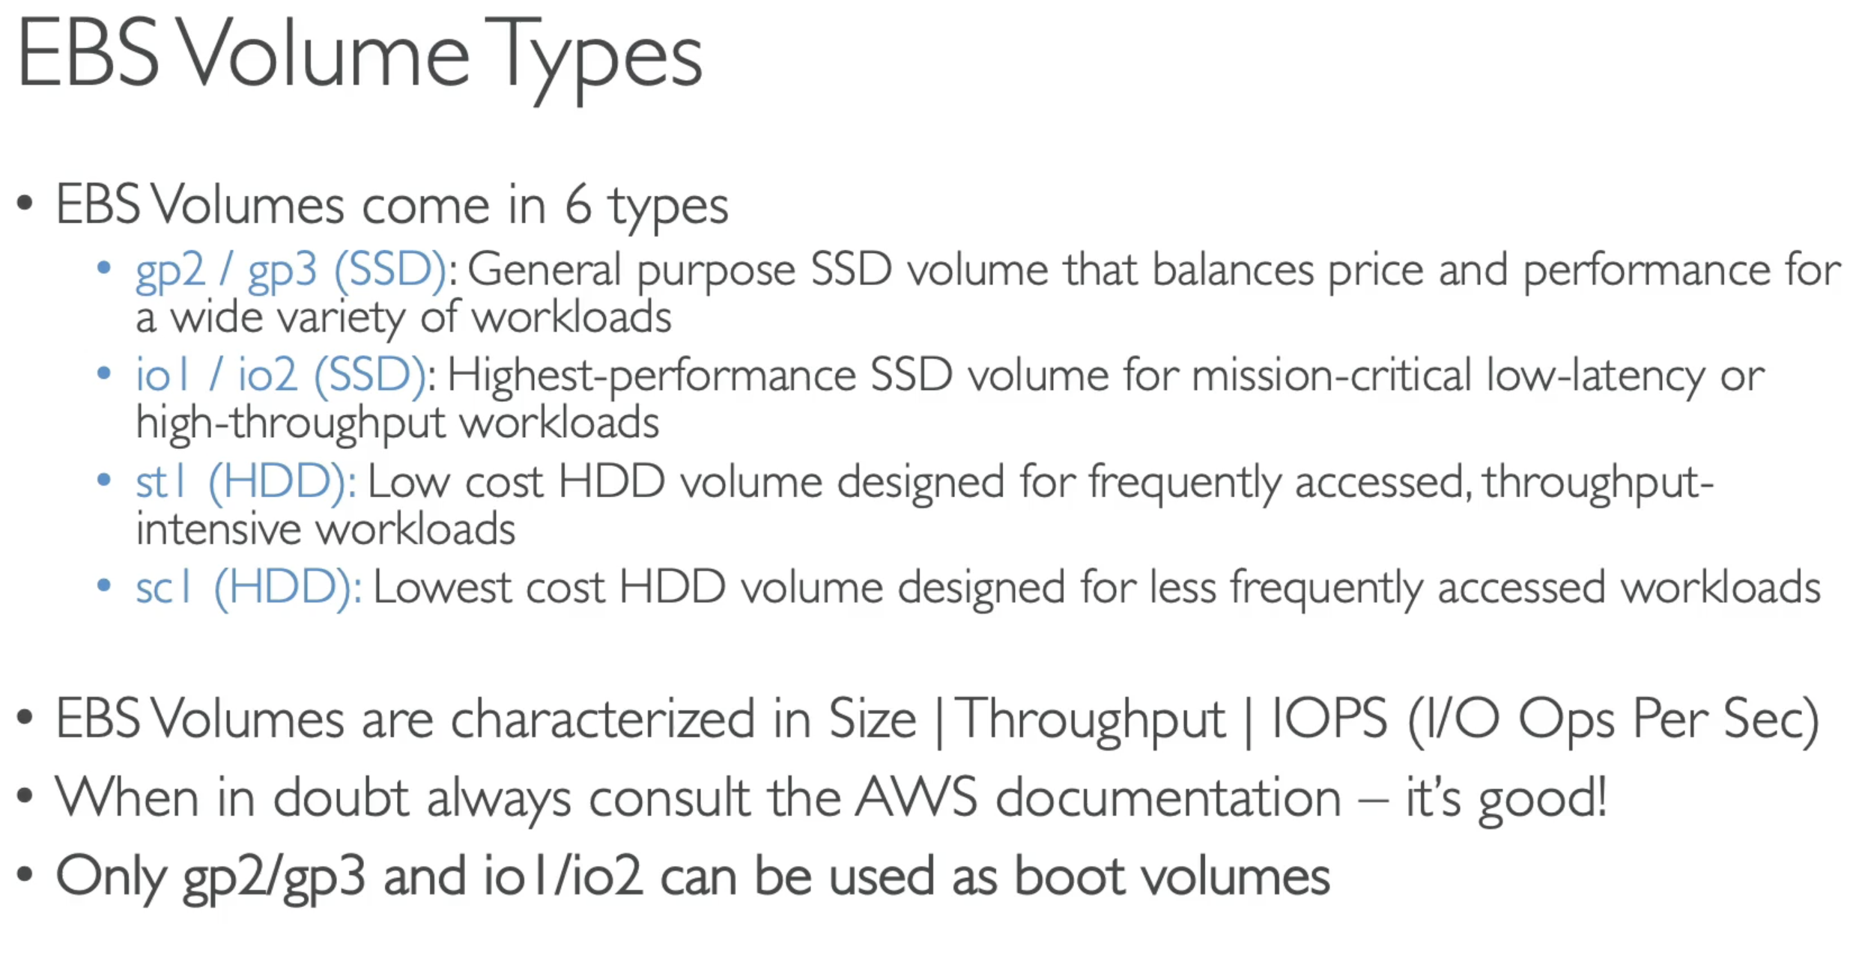

Remember that:

* Gp2/gp3 are cost effective storage, low latency
* In gp3 you can independently set the iops and throughputs
* In gp2 they are linked

### Provisioned IOPs

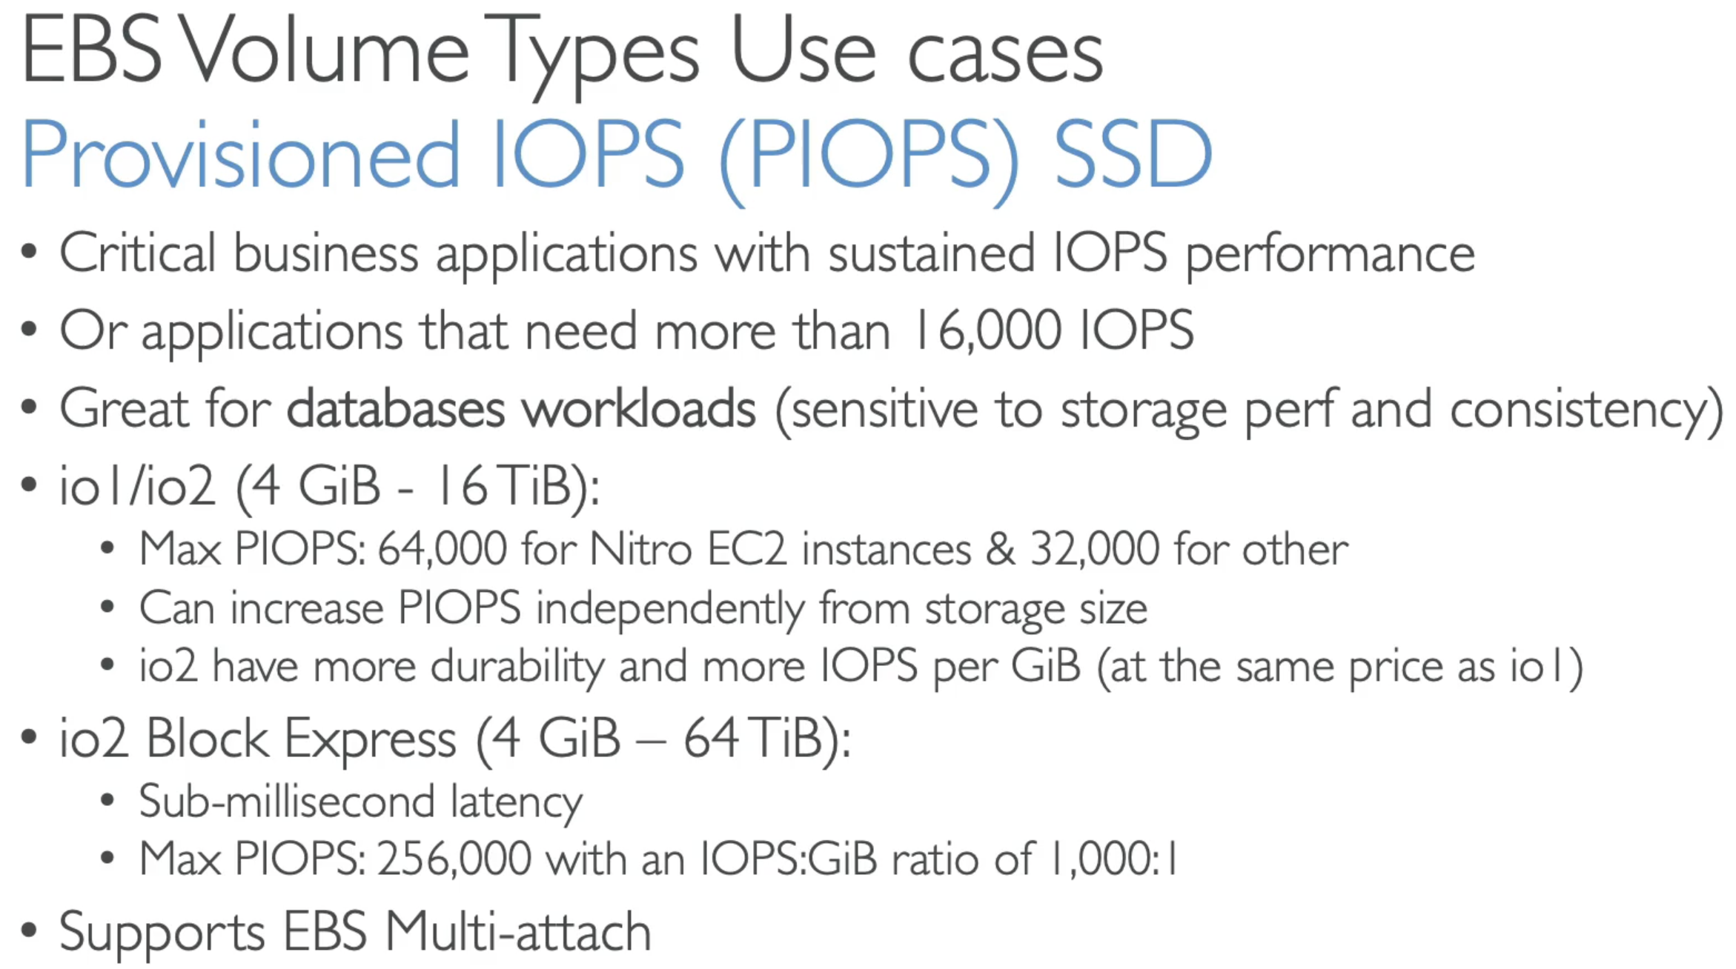

### Hard Disk Drive - HDD

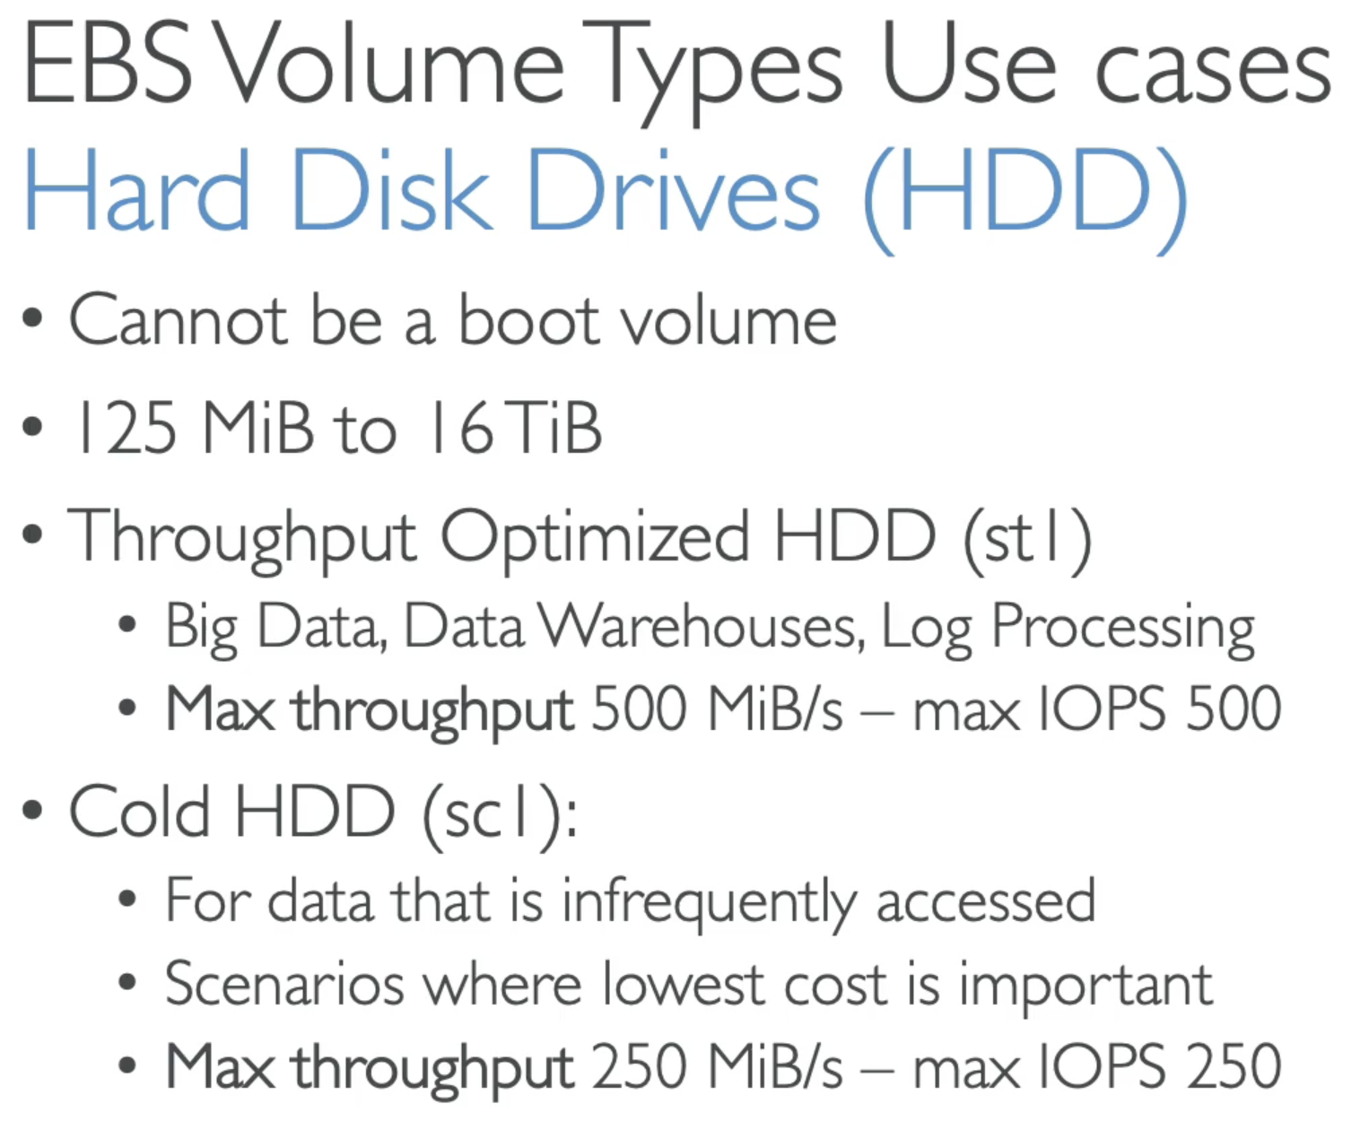

Remember that:

* If you want to get over 32,000 iops, you need EC2 Nitro with io1 or io2

## 62. EBS – Multi Attach

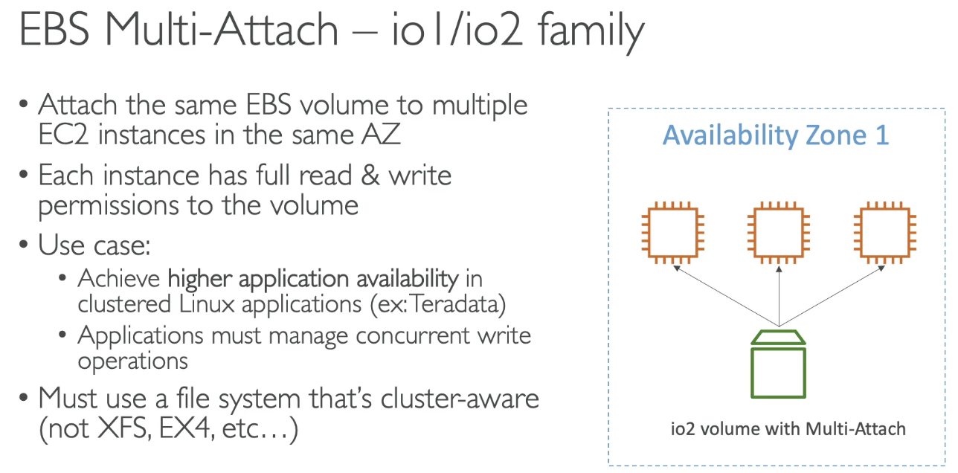

Remember that – you can attach a EBS volume to multiple EC2 instances, only if they are part of io1 and io2 family.

## 63. EBS Encryption

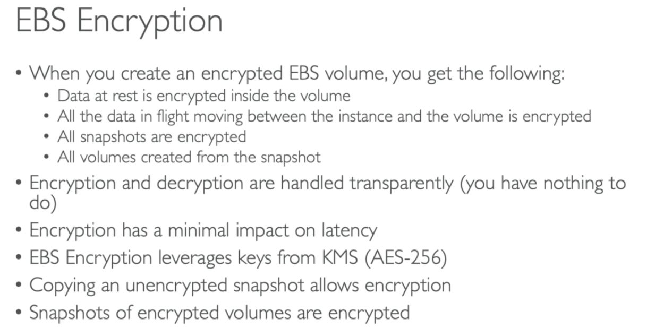

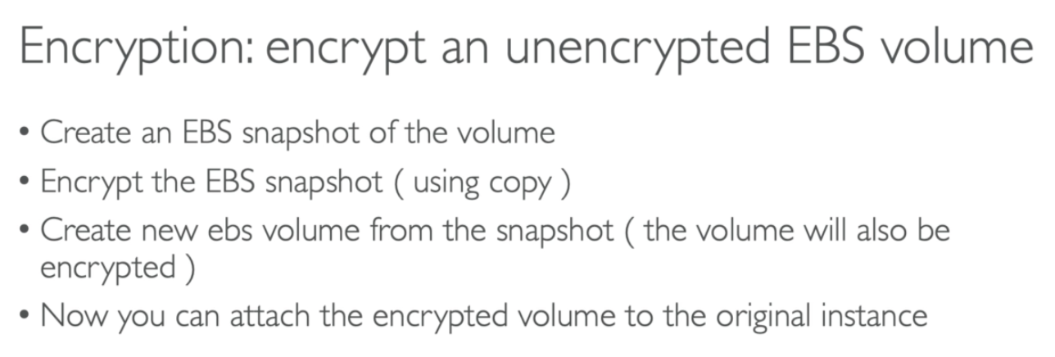

Shortcut:

* Take an unencrypted snapshot
* Right click 🡪 create a volume from it 🡪 select the check box – encryption

## 64. EBS RAID configurations

### RAID 0

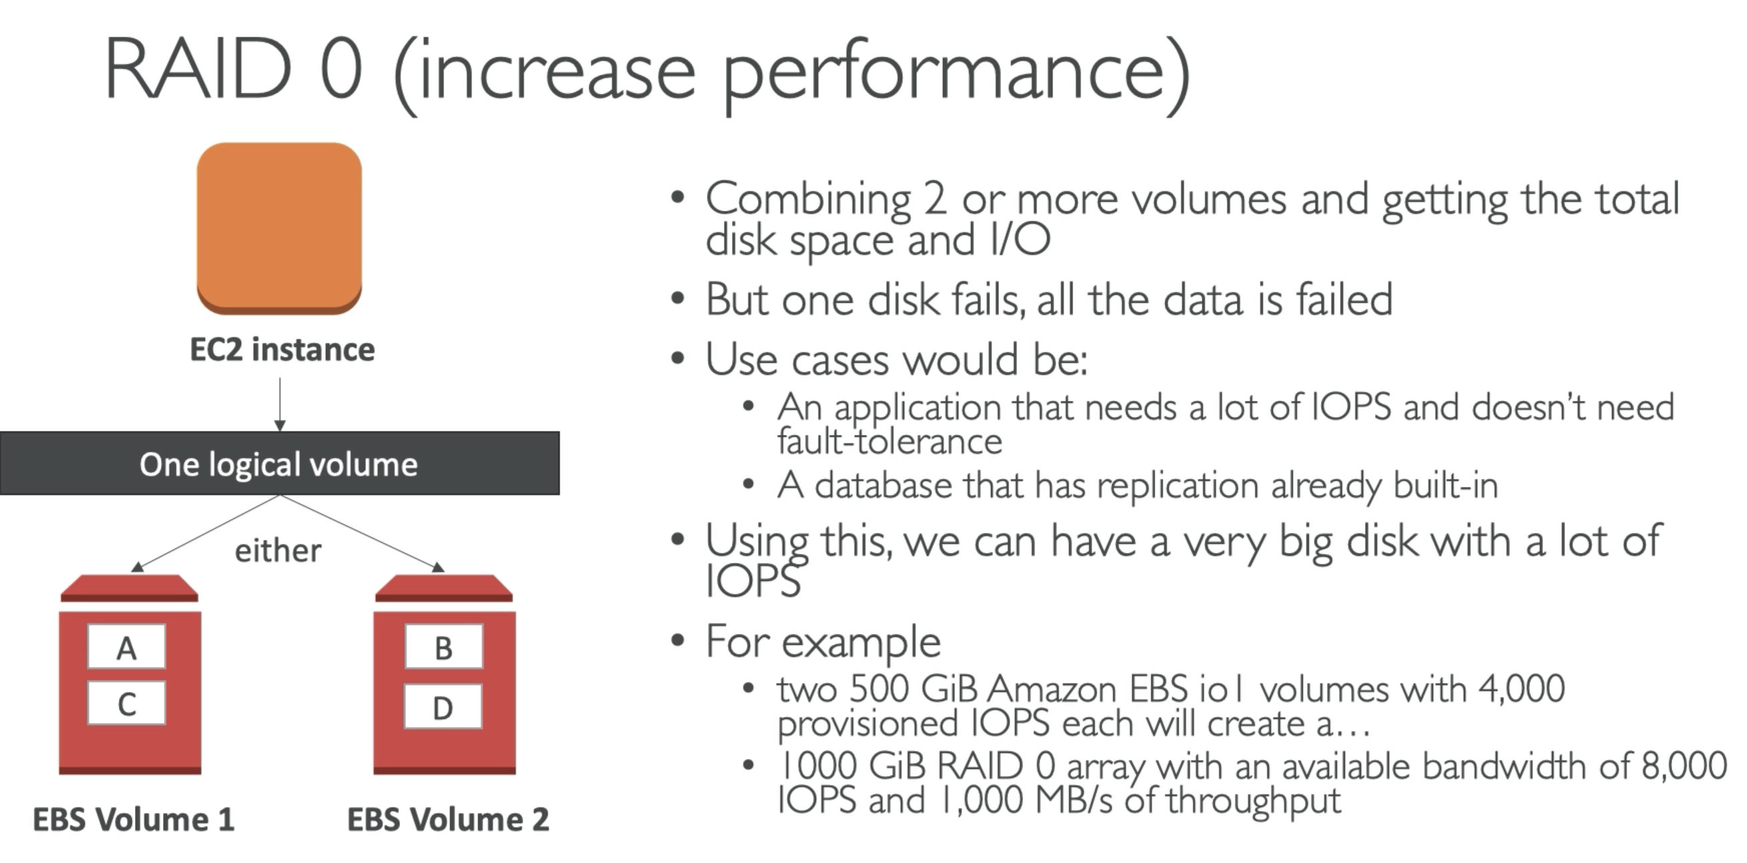

If we have 2 EBS volumes in RAID 0 mode, then its goin to sum up the size, disk space and IO

### RAID 1

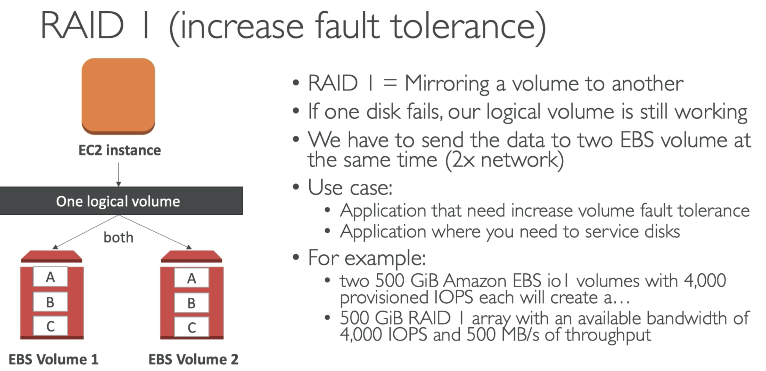

## 65. EFS Overview

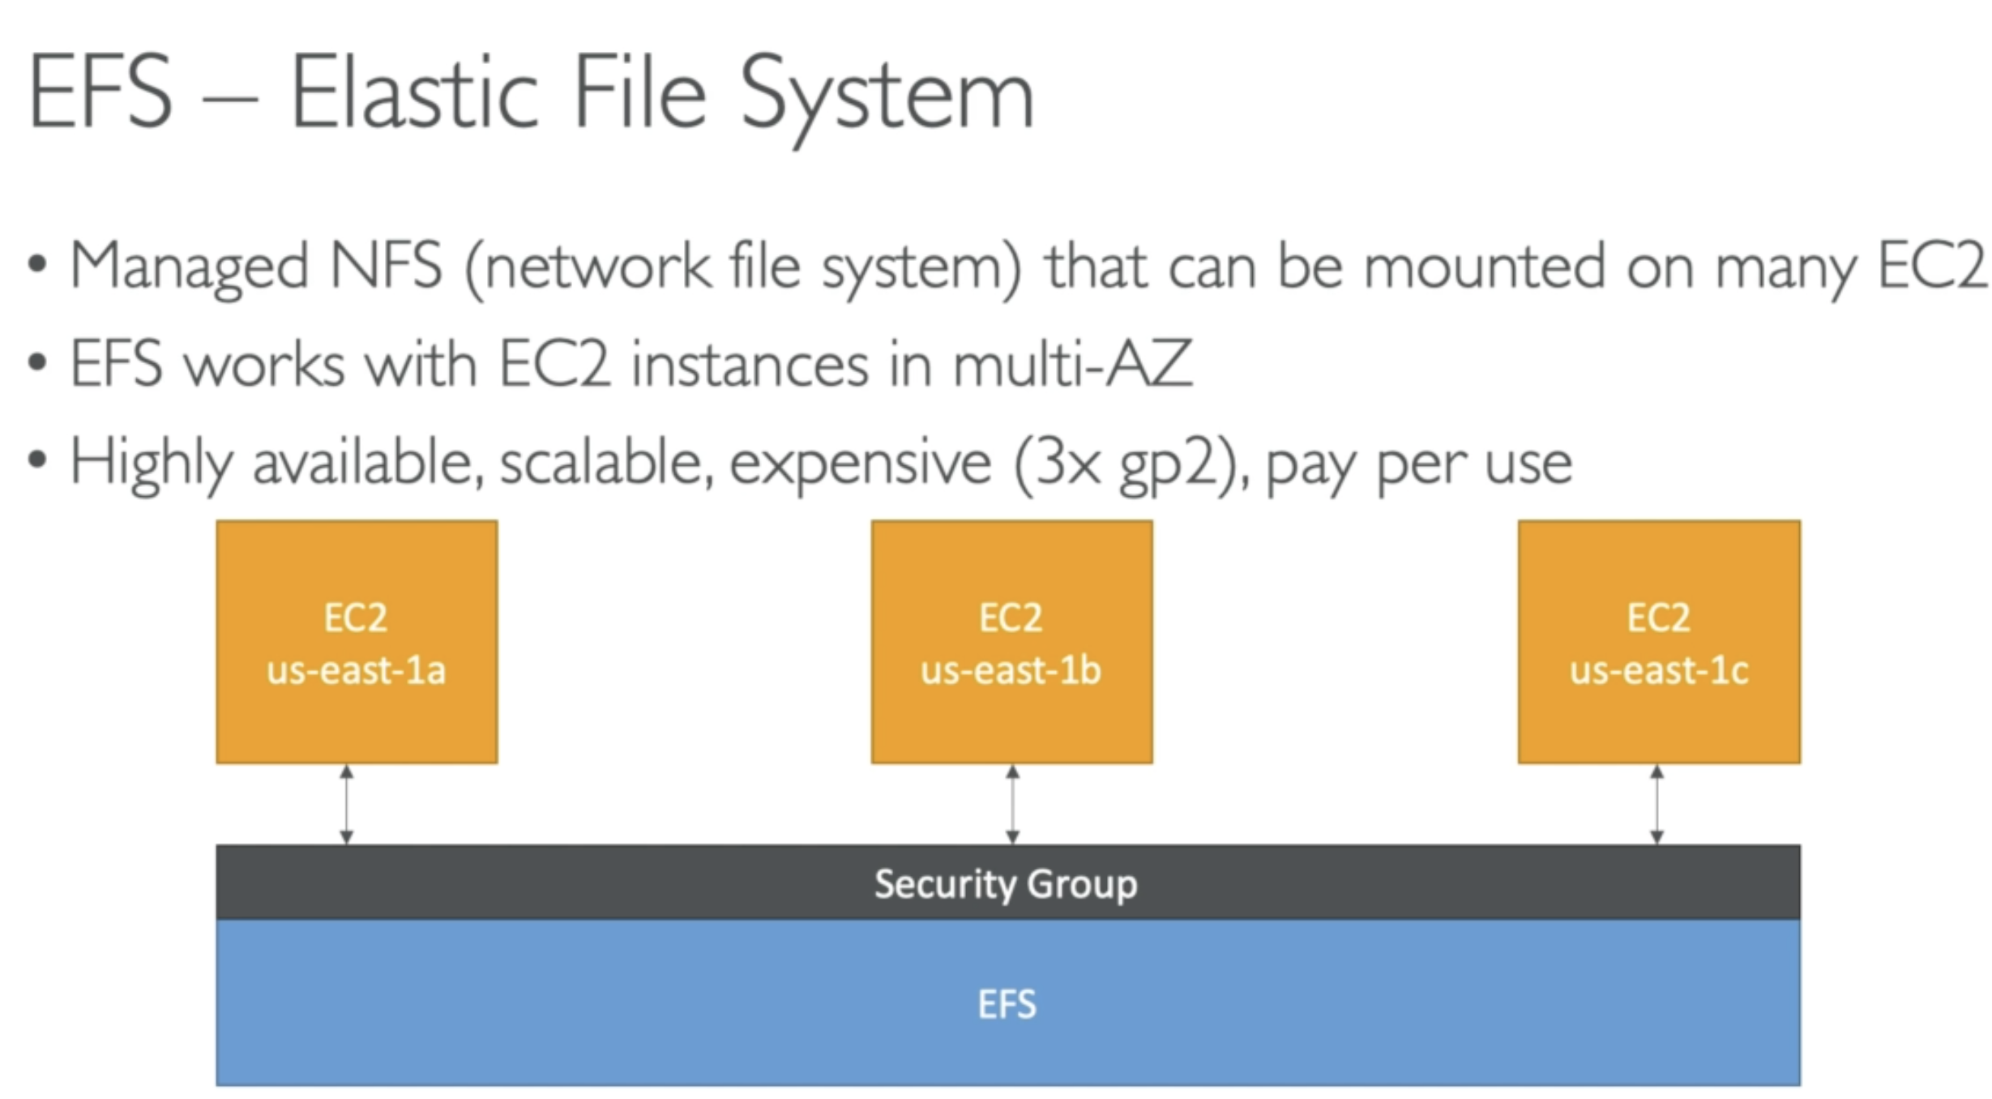

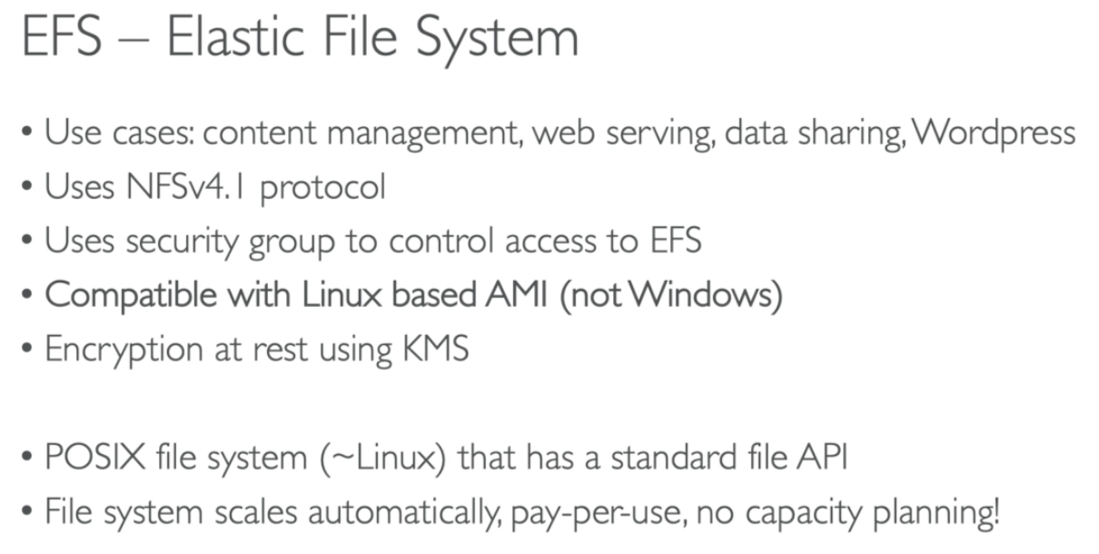

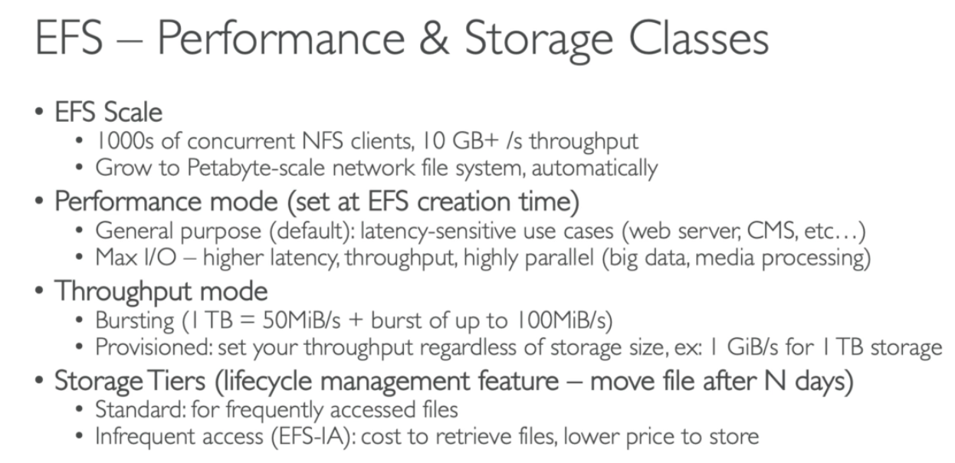

* If you have a small file system, but very high throughput 🡪 move to provision throughput mode for EFS

## 67. EBS vs EFS

